<!DOCTYPE html>

<html>

<head>

<title>Introducing CSS</title>

<link href="style1.css" type="text/css"

rel="stylesheet" />

</head>

<body>

<h1>From Garden to Plate</h1>

<p>A <i>potager</i> is a French term for an

ornamental vegetable or kitchen garden ... </p>

<h2>What to Plant</h2>

<p>Plants are chosen as much for their functionality

as for their color and form ... </p>

</body>

</html>

**CSS**

body {

font-family: Arial, Verdana, sans-serif;}

h1, h2 {

color: #ee3e80;}

p {

color: #665544;}

**From Garden to Plate**

A *potager* is a French term for an ornamental vegetable or kitchen garden ...

**What to Plant**

Plants are chosen as much for their functionality as for their color and form ...

<body>

<h1>Potatoes</h1>

<p>There are dozens of different potato

varieties. They are usually described as

early, second early and maincrop.</p>

</body>

**CSS**

body {

font-family: arial;

background-color: rgb(185,179,175);}

h1 {

color: rgb(255,255,255);}

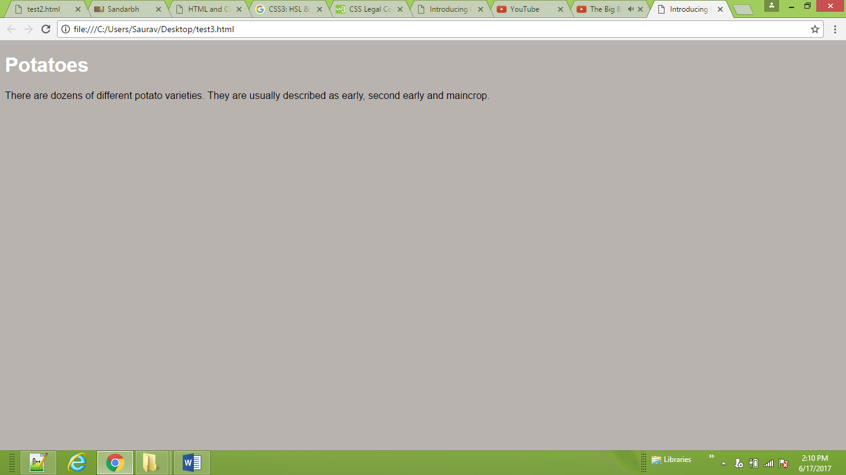

<!DOCTYPE html>

<html>

<head>

<title>Introducing CSS</title>

<link href="style1.css" type="text/css"

rel="stylesheet" />

</head>

<body>

<h1 id="top">Kitchen Garden Calendar</h1>

<p id="introduction">Here you can read our

handy guide about what to do when.</p>

<h2>Spring</h2>

<ul>

<li><a href="mulch.html">

Spring mulch vegetable beds</a></li>

<li><a href="potato.html">

Plant out early potatoes</a></li>

<li><a href="tomato.html">

Sow tomato seeds</a></li>

<li><a href="beet.html">

Sow beet seeds</a></li>

<li><a href="zucchini.html">

Sow zucchini seeds</a></li>

<li><a href="rhubarb.html">

Deadhead rhubarb flowers</a></li>

</ul>

<p class="note">

This page was written by

<a href="mailto:ivy@example.org">

ivy@example.org</a> for

<a href="http://www.example.org">Example</a>.

</p>

<p>

<a href="#top">Top of page</a>

</p>

</body>

</html>

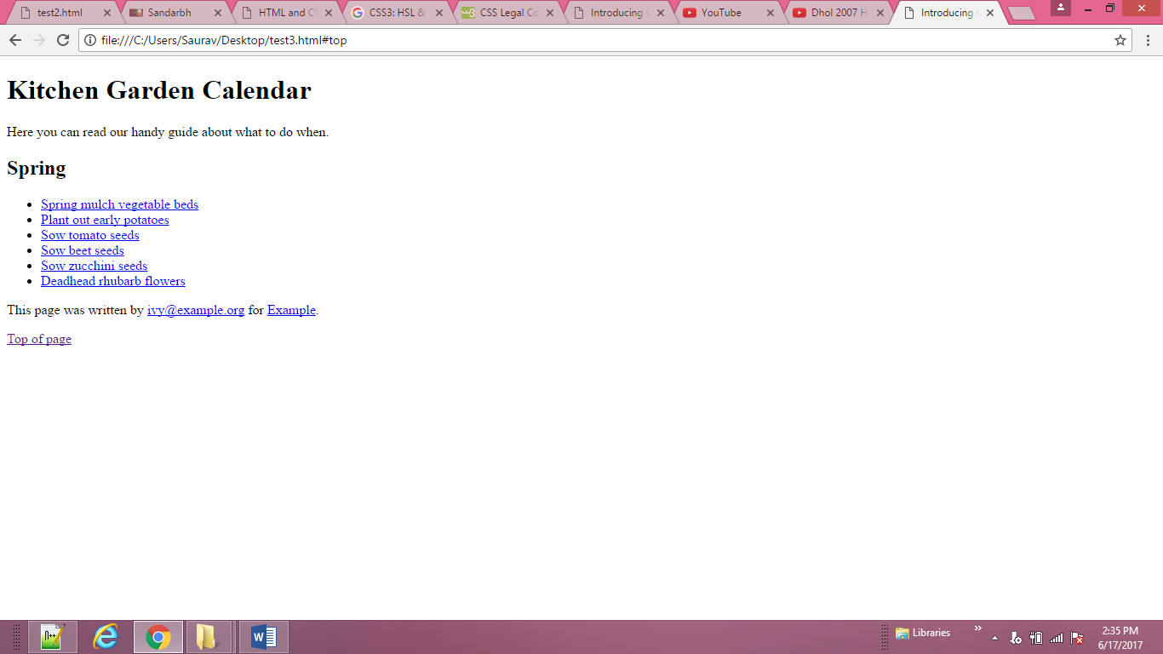

<!DOCTYPE html>

<html>

<head>

<title>Introducing CSS</title>

<link href="style1.css" type="text/css"

rel="stylesheet" />

</head>

<body>

<h1>Potatoes</h1>

<p id="intro">There are <i>dozens</i> of different

<b>potato</b> varieties.</p>

<p>They are usually described as early, second early

and maincrop potatoes.</p>

</body>

</html>

**CSS**

* {

font-family: Arial, Verdana, sans-serif;}

h1 {

font-family: "Courier New", monospace;}

i {

color: green;}

i {

color: red;}

b {

color: pink;}

p b {

color: blue !important;}

p b {

color: violet;}

p#intro {

font-size: 100%;}

p {

font-size: 75%;}

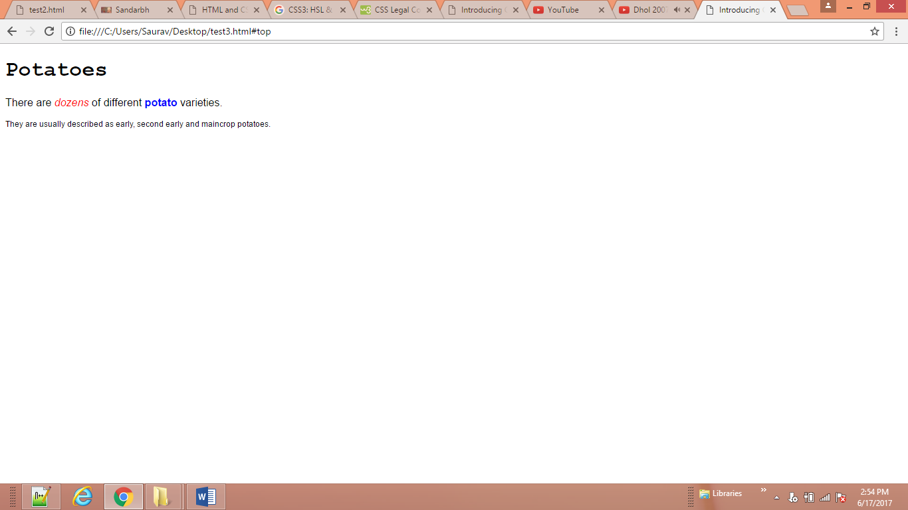

<body>

<div class="page">

<h1>Potatoes</h1>

<p>There are dozens of different potato

varieties.</p>

<p>They are usually described as early, second

early and maincrop potatoes.</p>

</div>

</body>

**CSS**

body {

font-family: Arial, Verdana, sans-serif;

color: #665544;

padding: 10px;}

.page {

border: 1px solid #665544;

background-color: #efefef;

padding: inherit;}

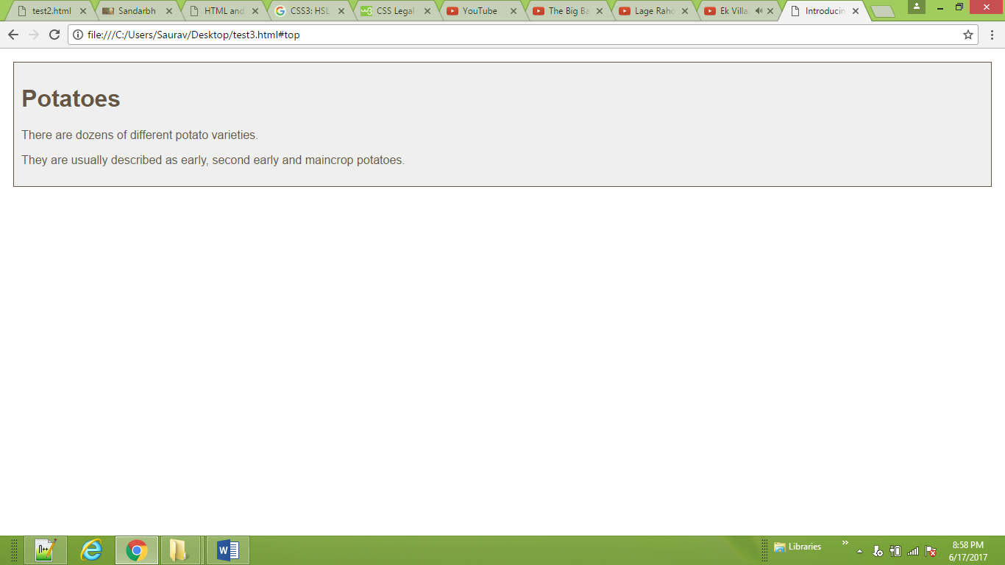

<body>

<h1>Potatoes</h1>

<h2>There are dozens of different potato

varieties.</h2>

<p>They are usually described as early, second

early and maincrop potatoes.</p>

</body>

**CSS**

/* color name */

h1 {

color: DarkCyan;}

/* hex code */

h2 {

color: #ee3e80;}

/* rgb value */

p {

color: rgb(100,100,90);}

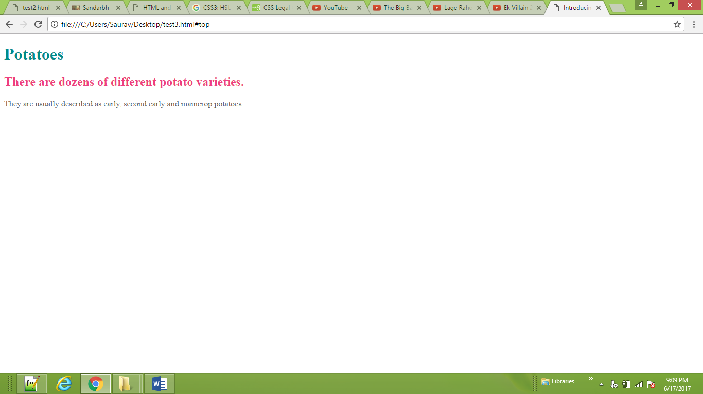

<body>

<h1>Potatoes</h1>

<h2>There are dozens of different potato

varieties.</h2>

<p>They are usually described as early, second

early and maincrop potatoes.</p>

</body>

**CSS**

body {

background-color: rgb(200,200,200);}

h1 {

background-color: DarkCyan;}

h2 {

background-color: #ee3e80;}

p {

background-color: white;}

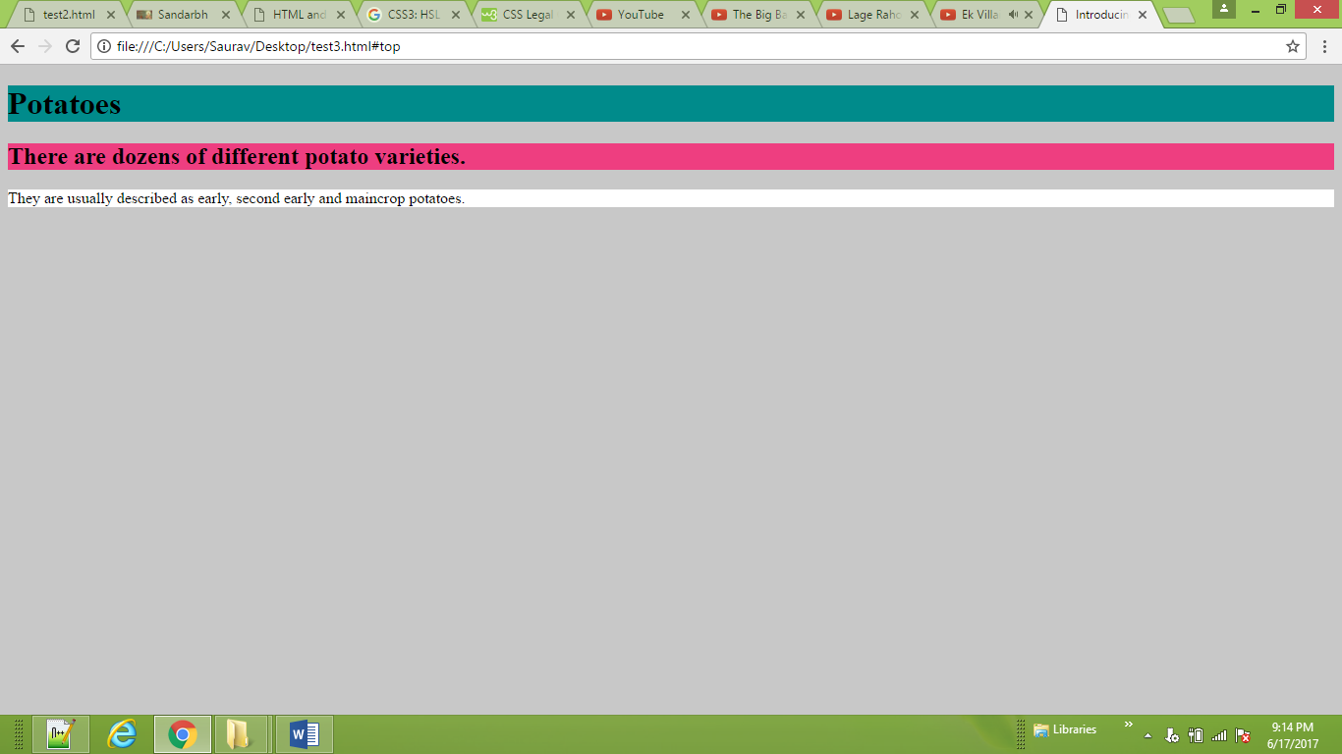

<body>

<div class="one">

<img src="ram/v.jpg" alt="Goku is Unbeatable" height="300" width="300"><br><br><br><br>

</div>

<div class="two">

<img src="ram/v.jpg" alt="Goku" title="gkennnekbnelknb"/ width="100" height="100" align="top">

</div>

</body>

**CSS**

**.one {**

**background-color: green;**

**opacity: 0.2;}**

**.two {**

**background-color: red;**

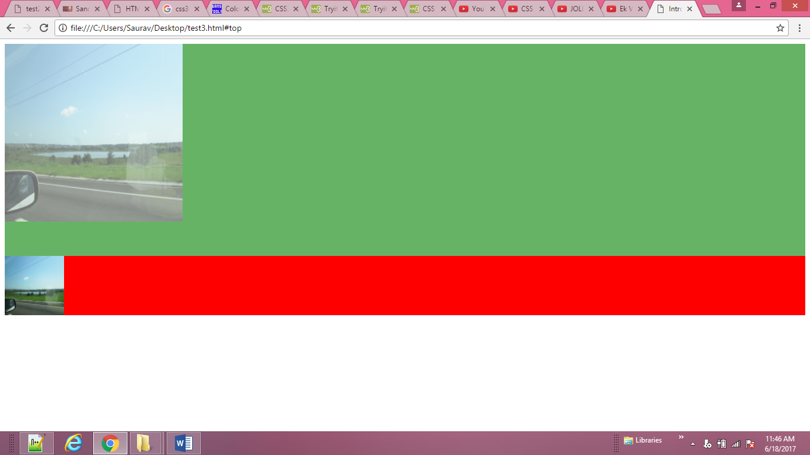

</head>

<body>

<h1>Potatoes</h1>

<h2>There are dozens of different potato

varieties.</h2>

<p>They are usually described as early, second

early and maincrop potatoes.</p>

</head>

**CSS**

body {

background-color: #C8C8C8;

background-color: hsl(0,0%,78%);}

p {

background-color: #ffffff;

background-color: hsla(0,100%,100%,0.3);}

h1 {

background-color: #00ff00;

background-color: hsla(120, 100%, 50%,0.3);}

h2 {

background-color: #65cdaa;

background-color: hsla(160, 51%, 60%,0.3);}

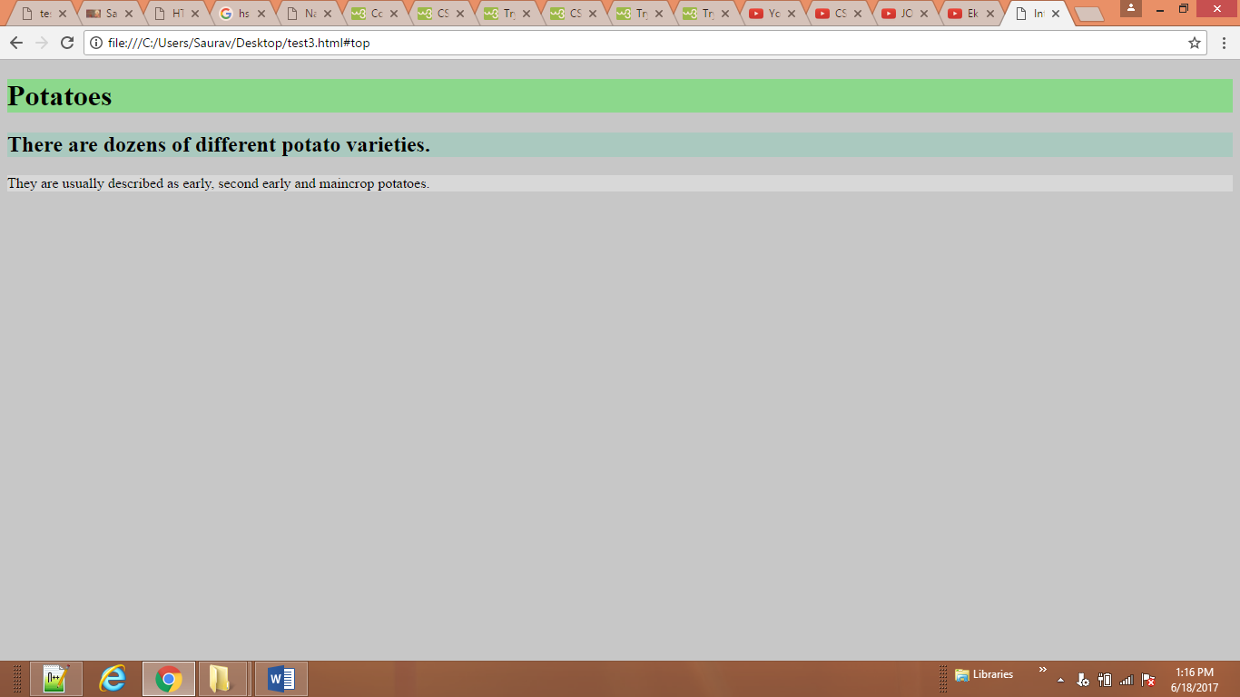

<body>

<h1>Briards</h1>

<p class="credits">by Ivy Duckett</p>

<p class="intro">The <a class="breed"

href="http://en.wikipedia.org/wiki/

Briard" target="blank">briard</a>, or berger de brie, is

a large breed of dog traditionally used as

a herder and guardian of sheep...</p>

</body>

**CSS**

body {

font-family: Georgia, Times, serif;

background-color: #C8C8C8;

background-color: hsl(0,0%,78%);}

h1, h2 {

font-family: Arial, Verdana, sans-serif;}

.credits {

font-family: "Courier New", Courier,

monospace;}

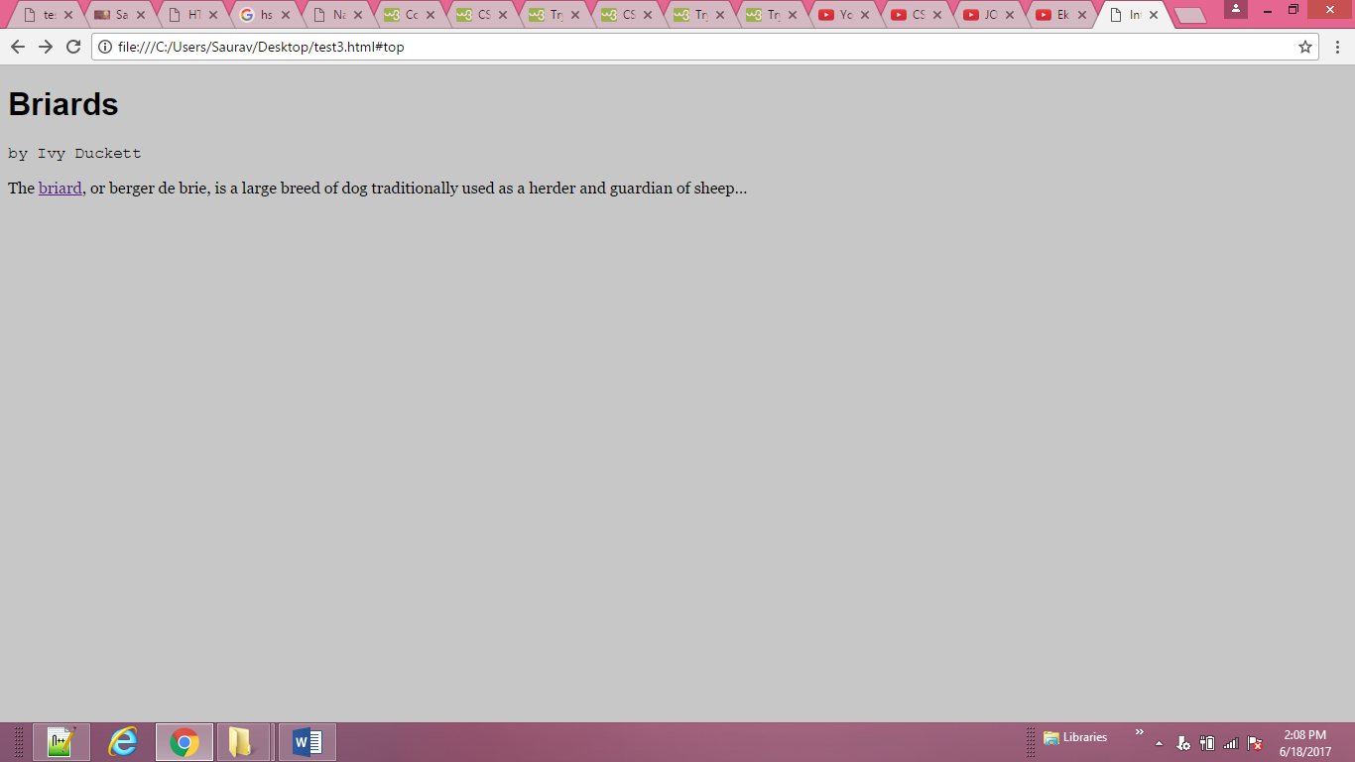

<body>

<h1>Briards</h1>

<p class="credits">by Ivy Duckett</p>

<p class="intro">The <a class="breed"

href="http://en.wikipedia.org/wiki/

Briard" target="blank">briard</a>, or berger de brie, is

a large breed of dog traditionally used as

a herder and guardian of sheep...</p>

</body>

**CSS**

body {

font-family: Arial, Verdana, sans-serif;

font-size: 12px;

background-color: #C8C8C8;

background-color: hsl(0,0%,78%);}

h1 {

font-size: 200%;}

p {

font-size: 1.2em;}

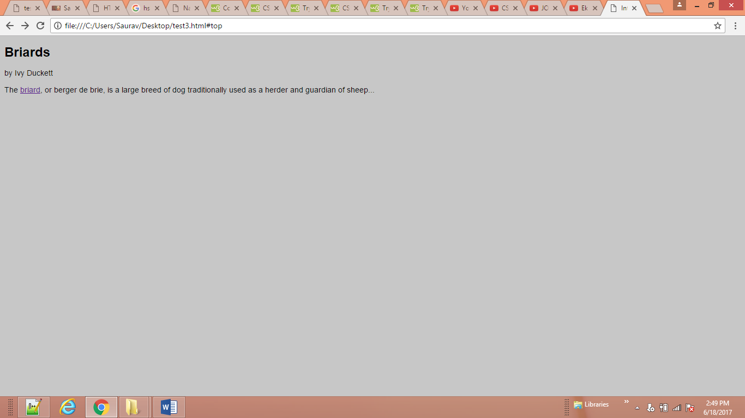

<body>

<h1>Briards</h1>

<p class="credits">by Ivy Duckett</p>

<p class="intro">The <a class="breed"

href="http://en.wikipedia.org/wiki/

Briard" target="blank">briard</a>, or berger de brie, is

a large breed of dog traditionally used as

a herder and guardian of sheep...</p>

</body>

**CSS**

.credits {

font-weight: bold;}

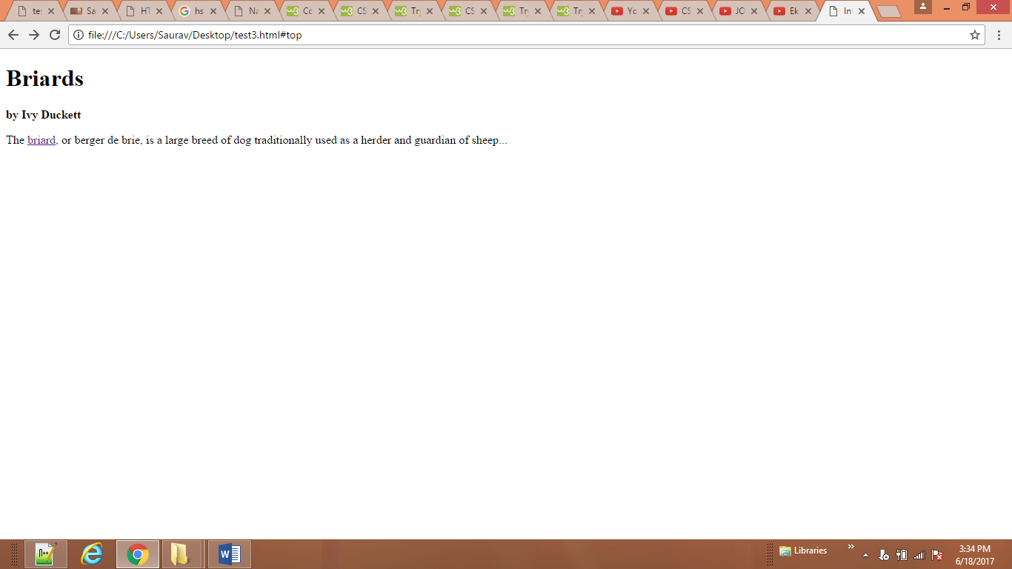

<body>

<h1>briards</h1>

<p class="credits">by Ivy Duckett</p>

<p class="intro">The <a class="breed"

href="http://en.wikipedia.org/wiki/

Briard" target="blank">briard</a>, or berger de brie, is

a large breed of dog traditionally used as

a herder and guardian of sheep... abfisdbieorngonewobnpnoewnbrimeowrnjenbnevngmnmabfisdbieorngbnevngmnmabfisdbieorn

abfisdbieorngonewobnpnoewnbrimeowrnjenbnevngmnmabfisdbieorngonewobnpnoewnbrimeowrnjenbnevngmnmabfisdbieorngonewobnpnoewnbrim

abfisdbieorngonewobnpnoewnbrimeowrnjenbnevngmnmabfisdbieorngonewobnpnoewnbrimeowrnjenbnevngmnm</p>

</body>

**CSS**

.credits {

font-weight: bold;

text-transform: uppercase;

text-decoration:underline; }

.intro {

font-style: italic;

text-transform: lowercase;

line-height:3.1em;}

h1{text-transform: capitalize;

}

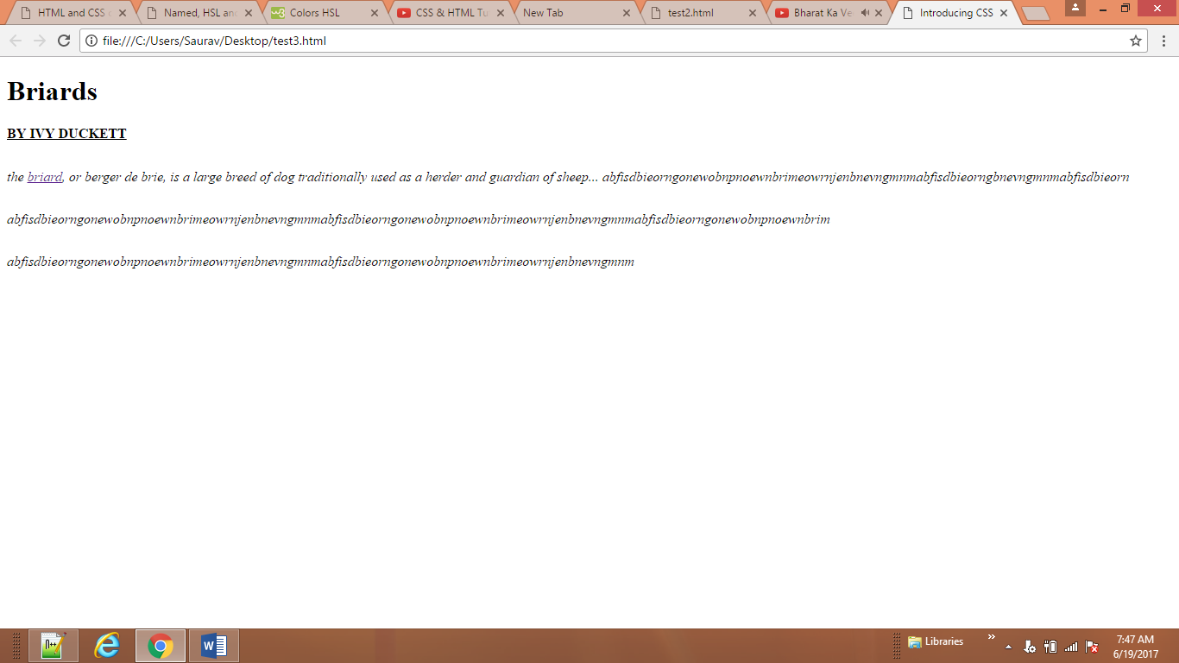

<body>

<h1>briards</h1>

<p class="credits">by Ivy Duckett</p>

<p>he <a class="breed"

href="http://en.wikipedia.org/wiki/

Briard" target="blank">briard</a>, or berger de brie, is

a large breed of dog traditionally used as

a herder and guardian of sheep... abfisdbieorngonewobnpnoewnbrimeowrnjenbnevngmnmabfisdbieorngbnevngmnmabfisdbieorn

abfisdbieorngonewobnpnoewnbrimeowrnjenbnevngmnmabfisdbieorngonewobnpnoewnbrimeowrnjenbnevngmnm</p>

</body>

**CSS**

h1 {

text-align: left;}

p {

text-align: justify;}

.credits {

text-align: right;}

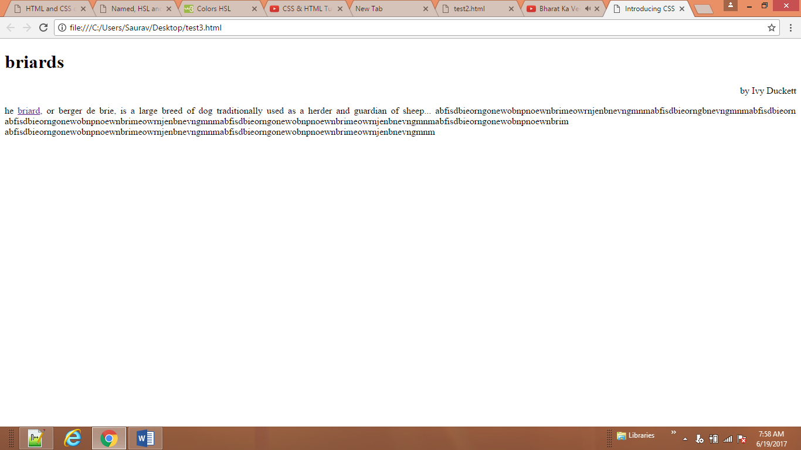

</head>

<body>

<p> <img class="one" src="ram/facebook.png" alt="Bird" width="100"

height="100"/>This is Sandarbh Kapur</p>

<p><img class="two" src="ram/facebook.png" alt="Bird" width="100"

height="100"/>This is Sandarbh Kapur</p>

<p><img class="three" src="ram/facebook.png" alt="Bird" width="100"

height="100"/>This is Sandarbh Kapur</p>

</body>

**CSS**

.one {

vertical-align: text-top;}

.two {

vertical-align: middle;}

.three {

vertical-align: text-bottom;}

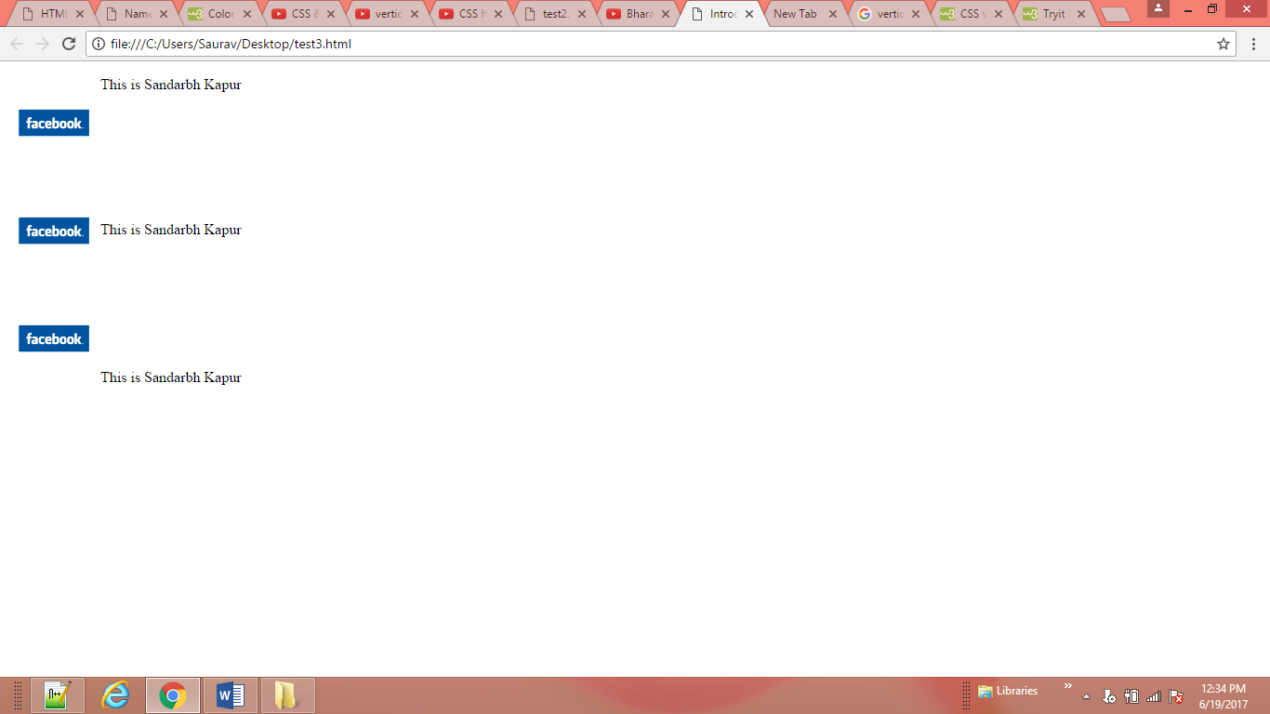

<body>

<p> This is sandarbh kapur This is sandarbh kapur This is sandarbh kapur This is sandarbh kapur

This is sandarbh kapur This is sandarbh kapur This is sandarbh kapur This is sandarbh kapur This is sandarbh kapur

This is sandarbh kapur This is sandarbh kapur This is sandarbh kapur </p>

</body>

**CSS**

p{ text-indent:100px;}

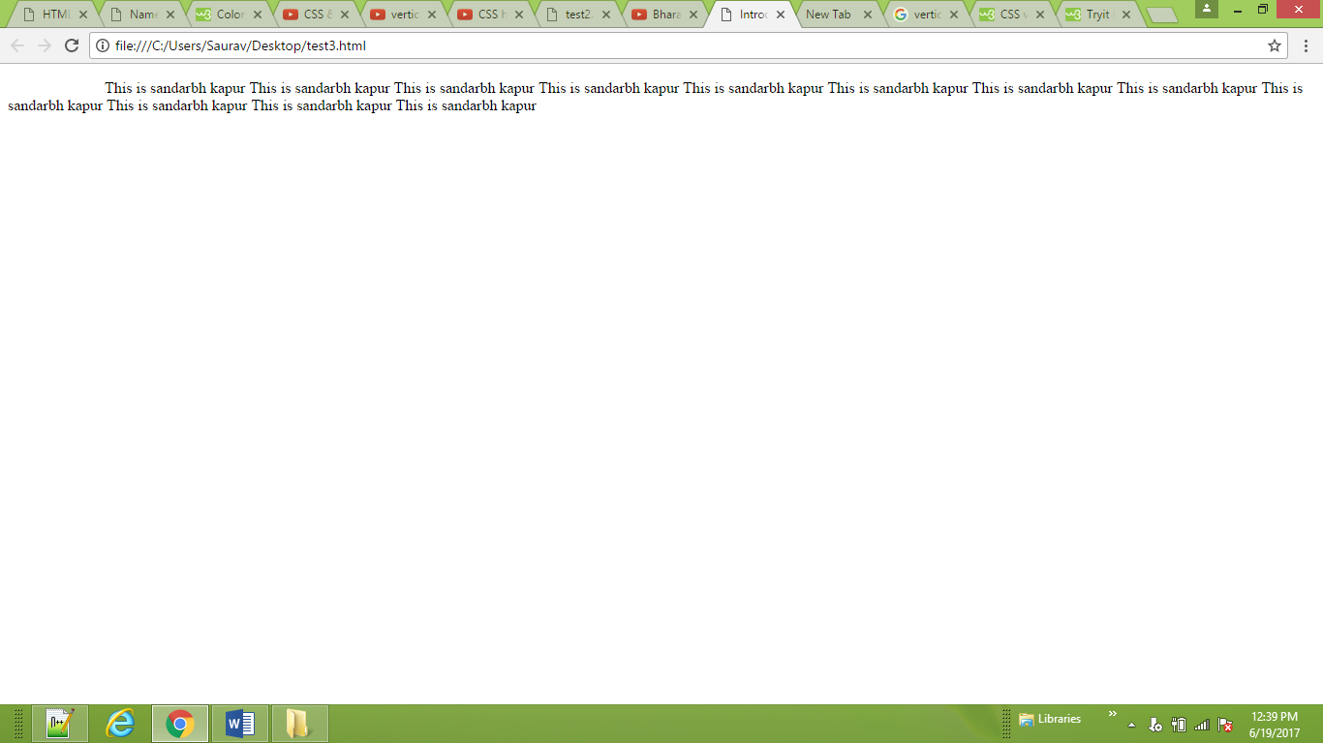

<body>

<h1> This is sandarbh kapur </h1> <br><br>

<h2> This is sandarbh kapur </h2> <br><br>

<h3> This is sandarbh kapur </h3> <br><br>

<h4> This is sandarbh kapur </h4> <br><br>

<h5> This is sandarbh kapur </h5> <br><br>

</body>

**CSS**

h1{background-color: #eeeeee;

color: #666666;

text-shadow: -15px -15px 1px #000000;}

h2 {

background-color: #dddddd;

color: #666666;

text-shadow: 0 0 3px #FF0000;}

h3 {

background-color: #2A98FF;

color: #ffffff;

text-shadow: 2px 2px 7px #111111;}

h4 {

background-color: #bbbbbb;

color: #2A98FF;

text-shadow: -1px -2px #666666;}

h5 {

background-color: #aaaaaa;

color: #ffffff;

text-shadow: -1px -10px #666666;}

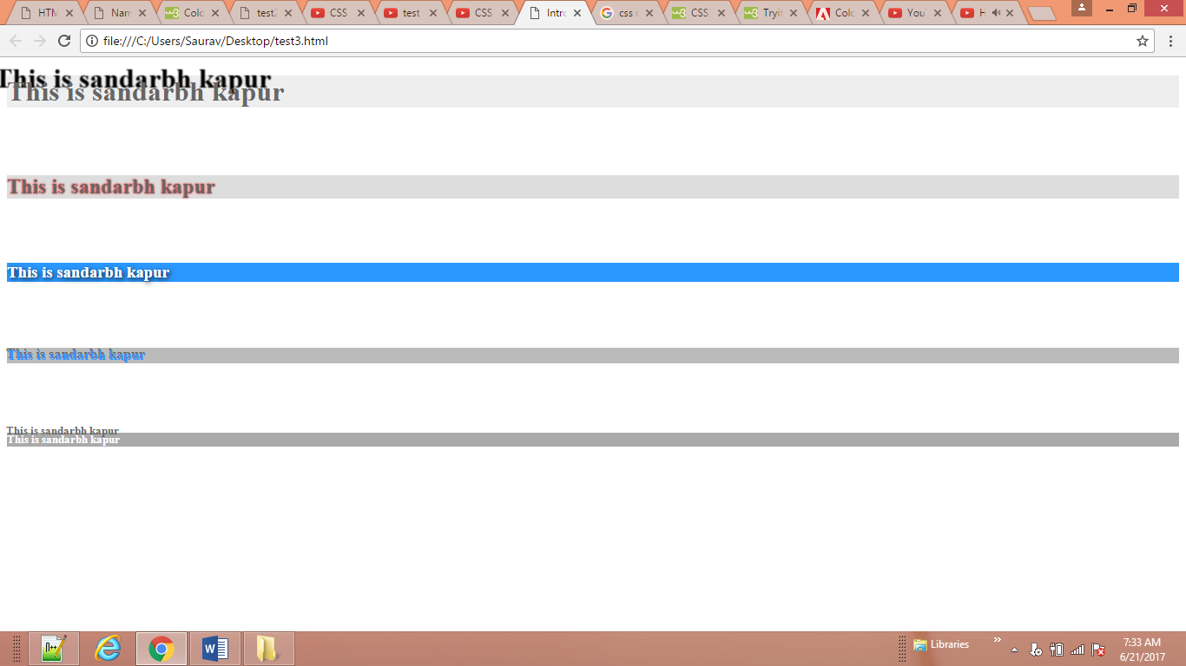

<body>

<p class="one"> This is sandarbh kapur This is sandarbh kapur This is sandarbh kapur This is sandarbh kapur This is sandarbh kapur

This is sandarbh kapur This is sandarbh kapur This is sandarbh kapur This is sandarbh kapur This is sandarbh kapur <p>

</body>

**CSS**

.one:first-letter {

font-size: 200%;

color: #8A2BE2;

}

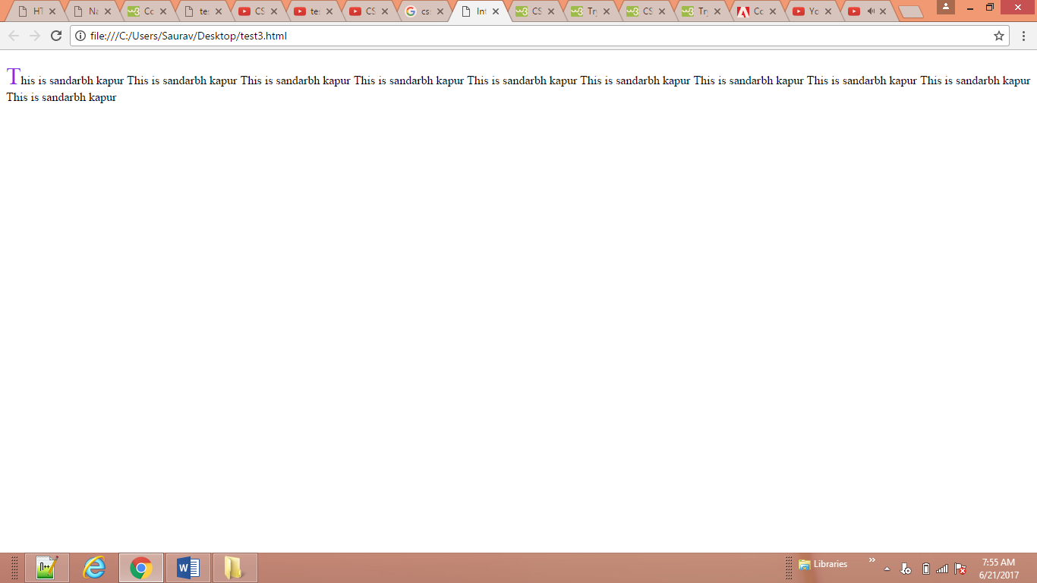

<body>

<p class="two"> This is sandarbh kapur This is sandarbh kapur This is sandarbh kapur This is sandarbh kapur This is sandarbh kapur

This is sandarbh kapur This is sandarbh kapur This is sandarbh kapur This is sandarbh kapur This is sandarbh kapur <p>

</body>

**CSS**

.two:first-line {

background-color: yellow;

font-weight:bold;

}

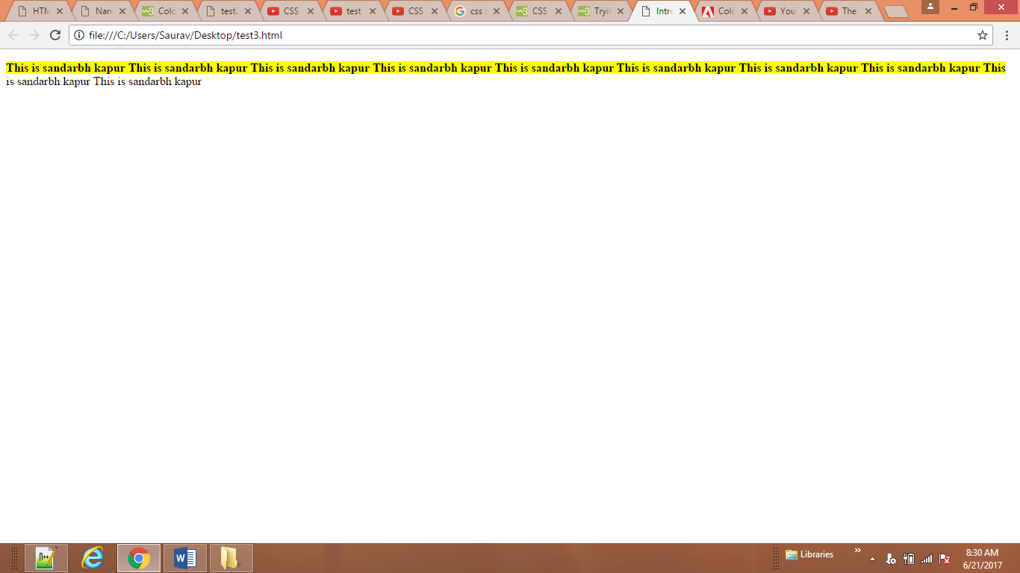

<body>

<p> Movie Review : </p>

<ul>

<li><a href="change1.html" target="blank"> Waqt </a> </li>

<li><a href="#" target="blank"> Raaz</a> </li>

<li><a href="#" target="blank"> Don</a> </li>

<li><a href="https://www.google.com/" target="blank"> Don2</a> </li>

</ul>

</body>

**CSS**

a:link {color: deeppink;

text-decoration: none;}

a:visited { color: yellow;}

a:hover { color: deeppink;

text-decoration: underline;}

a:active { color: darkcyan;}

a:link { background-color: grey;

}

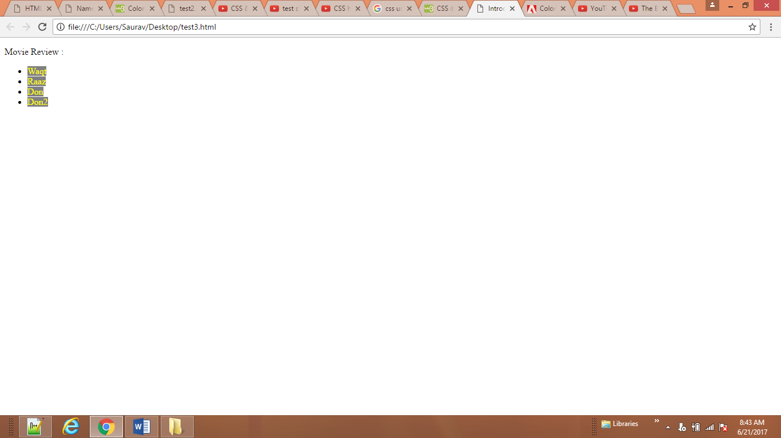

<body>

<form>

<input type="password" name="password" required="required"/>

<button type="submit" value="submit">Submit</button>

</form>

**CSS**

**button:hover {**

**background-color: #665544;}**

**button:active {**

**background-color: chocolate;}**

**button{ color: red;**

**font-weight: bold;**

**font-size: 150%;**

**text-transform:uppercase;**

**background-color: silver;**

**}**

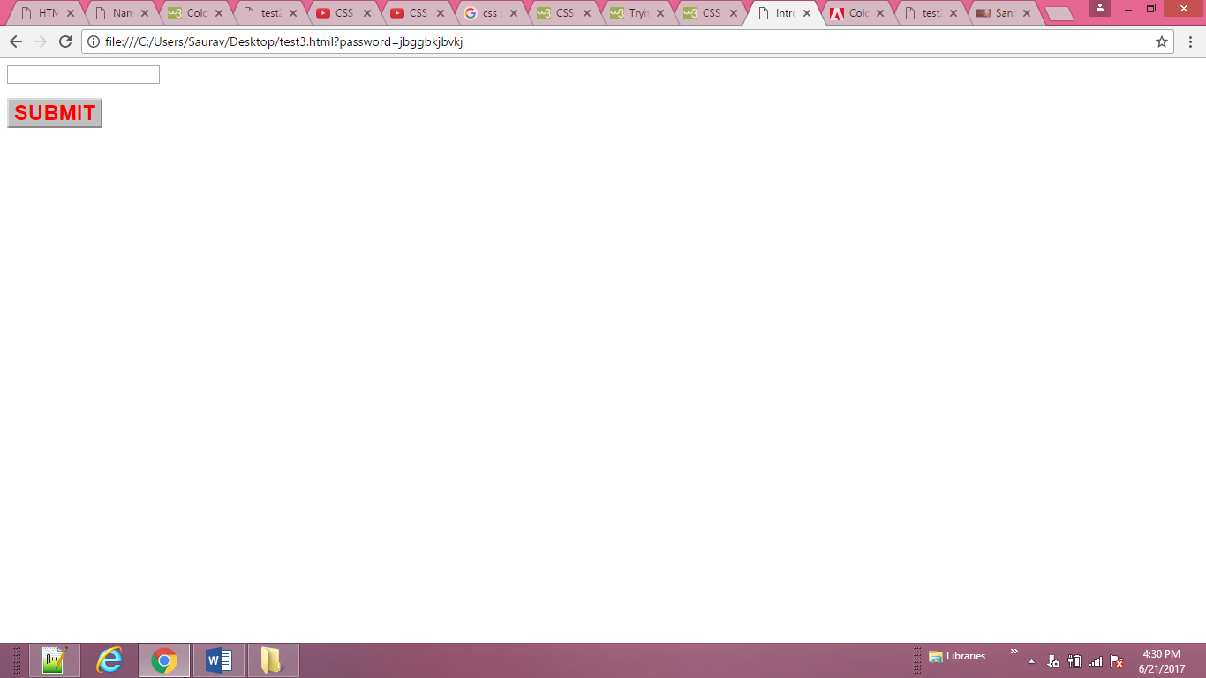

<body>

<div class="box">

<p>The Moog company pioneered the commercial

manufacture of modular voltage-controlled

analog synthesizer systems in the early

1950s.</p>

</div>

</body>

**CSS**

**div.box {**

**height: 300px;**

**width: 300px;**

**background-color: #bbbbaa;}**

**p {**

**height: 75%;**

**width: 75%;**

**background-color: #0088dd;}**

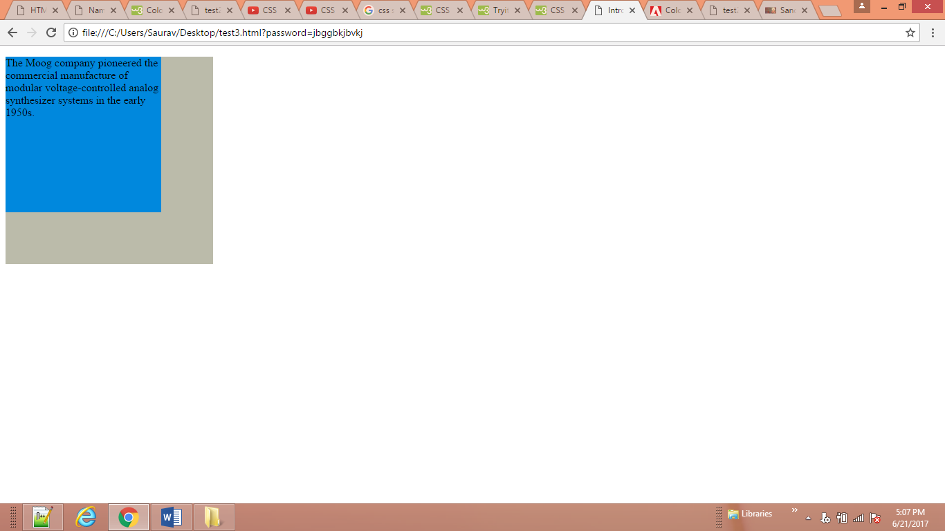

<body>

<tr>

<td><img src="ram/feild.jpg" width="200"

height="100" alt="Fender Rhodes" /></td>

<td class="description">The Rhodes piano is an

electro-mechanical piano, invented by Harold

Rhodes during the fifties and later

manufactured in a number of models ...</td>

<td>$1400</td>

</tr>

</body>

**CSS**

**td.description {**

**min-width: 450px;**

**max-width: 650px;**

**text-align: left;**

**padding: 5px;**

**margin: 0px;}**

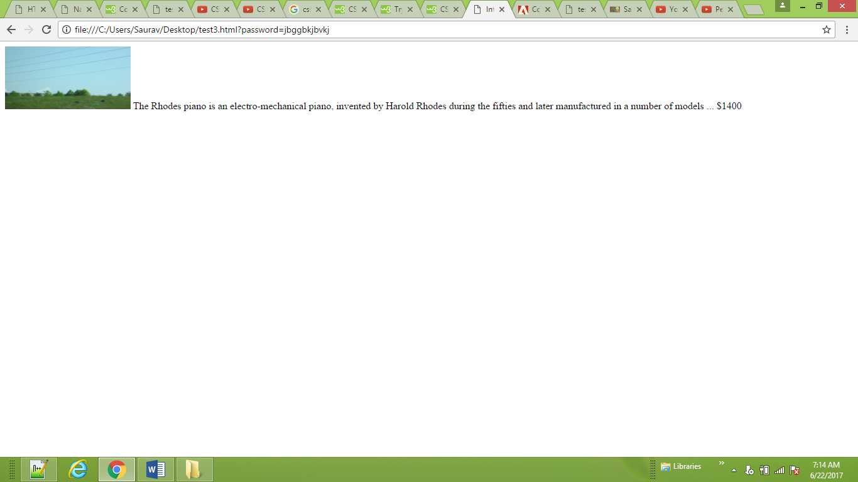

**<body>**

**<h2>Fender Mustang</h2>**

**<p>The Fender Mustang was introduced in 1964 as the**

**basis of a major redesign of Fender's ...</p>**

**<h2>Fender Stratocaster</h2>**

**<p>The Fender Stratocaster or "Strat" is one of the**

**most popular electric guitars of all time ...</p>**

**<h2>Gibson Les Paul</h2>**

**<p>The Gibson Les Paul is a solid body electric**

**guitar that was first sold in 1952 ...</p>**

**</body>**

**CSS**

**h2, p {width: 400px;**

**font-size: 90%;**

**line-height: 1.2em;}**

**h2 {color: #0088dd;**

**border-bottom: 1px solid #0088dd;}**

**p {min-height: 10px;**

**max-height: 30px;}**

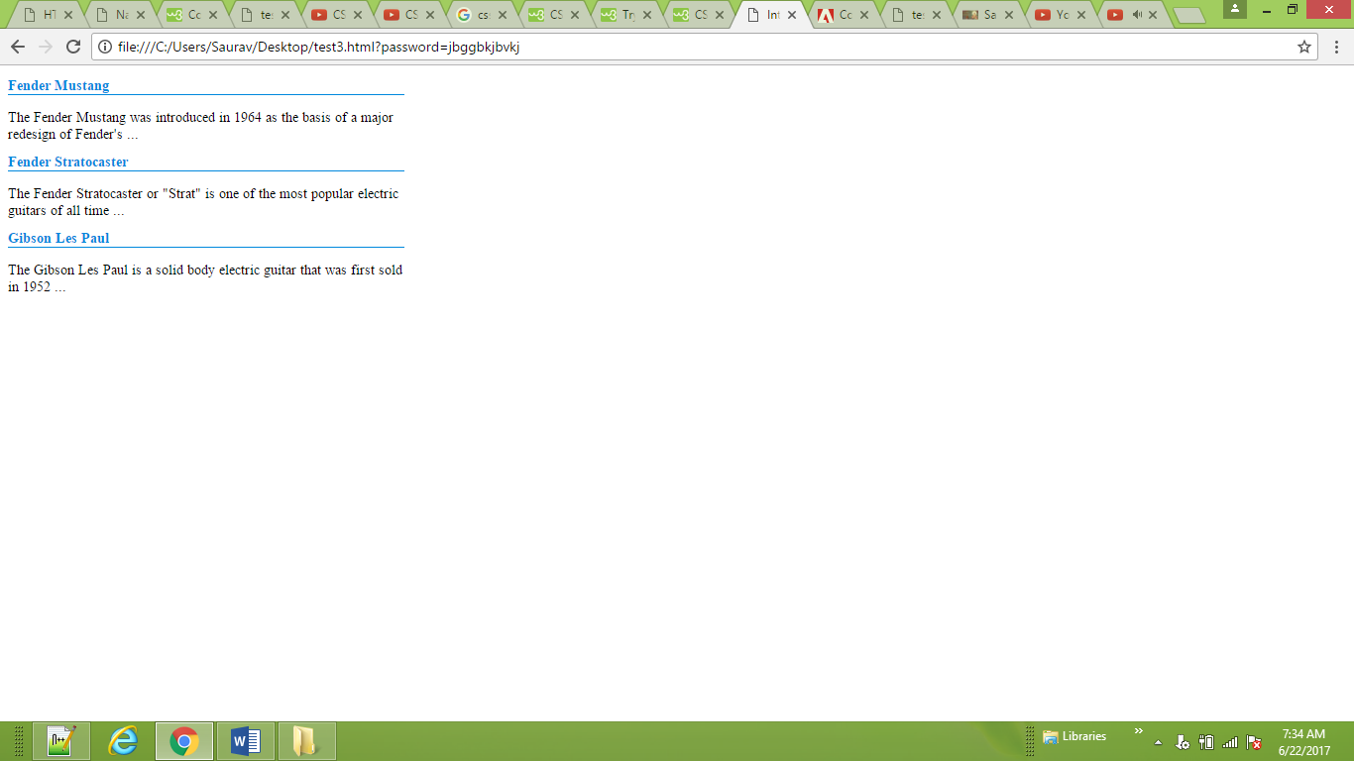

**<**body>

<h2>Fender Stratocaster</h2>

<p class="one">The Fender Stratocaster or "Strat" is one of the most popular electric guitars of

all time, and its design has been copied by many guitar makers. It was designed by Leo... </p>

<h2>Gibson Les Paul</h2>

<p class="two">The Gibson Les Paul is a solid body electric guitar that was first sold in 1952.

The Les Paul was designed by Ted McCarty... The Gibson Les Paul is a solid body

electric guitar that was first sold in 1952.</p>

</body>

**CSS**

p.one {

overflow: hidden;}

p.two {

overflow: scroll;}

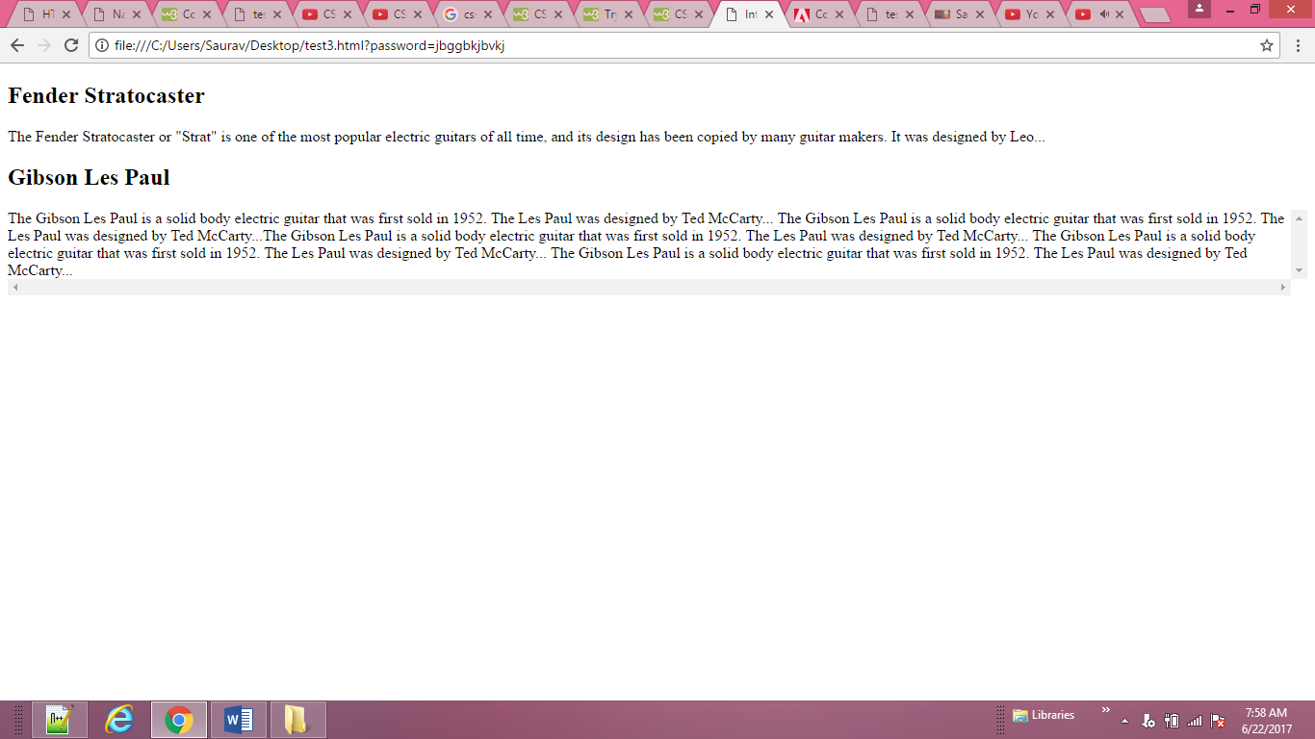

<body>

<p class="one">Hohner's "Clavinet" is essentially an

electric clavichord.</p>

<p class="two">Hohner's "Clavinet" is essentially an

electric clavichord.</p>

<p class="three">Hohner's "Clavinet" is essentially

an electric clavichord.</p>

</body>

**CSS**

p.one {border-style: solid;

border-width: 2px;}

p.two {border-style: solid;

border-width: thick;}

p.three {border-style: solid;

border-width: 1px 4px 12px 4px;}

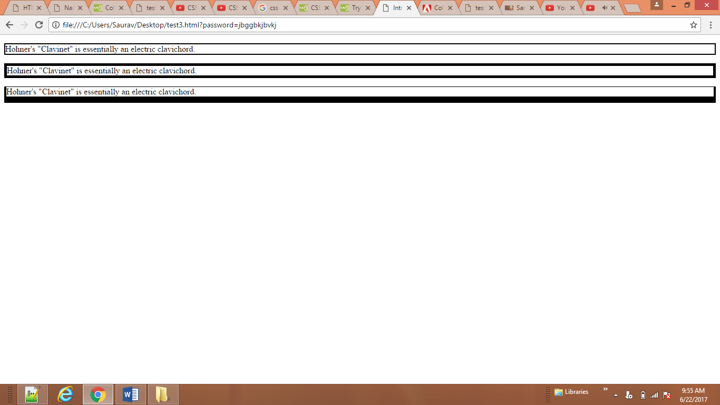

<body>

<p class="one">Wurlitzer Electric Piano</p>

<p class="two">Wurlitzer Electric Piano</p>

<p class="three">Wurlitzer Electric Piano</p>

<p class="four">Wurlitzer Electric Piano</p>

<p class="five">Wurlitzer Electric Piano</p>

<p class="six">Wurlitzer Electric Piano</p>

<p class="seven">Wurlitzer Electric Piano</p>

<p class="eight">Wurlitzer Electric Piano</p>

</body>

**CSS**

**p.one {border-style: solid;}**

**p.two {border-style: dotted;}**

**p.three {border-style: dashed;}**

**p.four {border-style: double;}**

**p.five {border-style: groove;}**

**p.six {border-style: ridge;}**

**p.seven {border-style: inset;}**

**p.eight {border-style: outset;}**

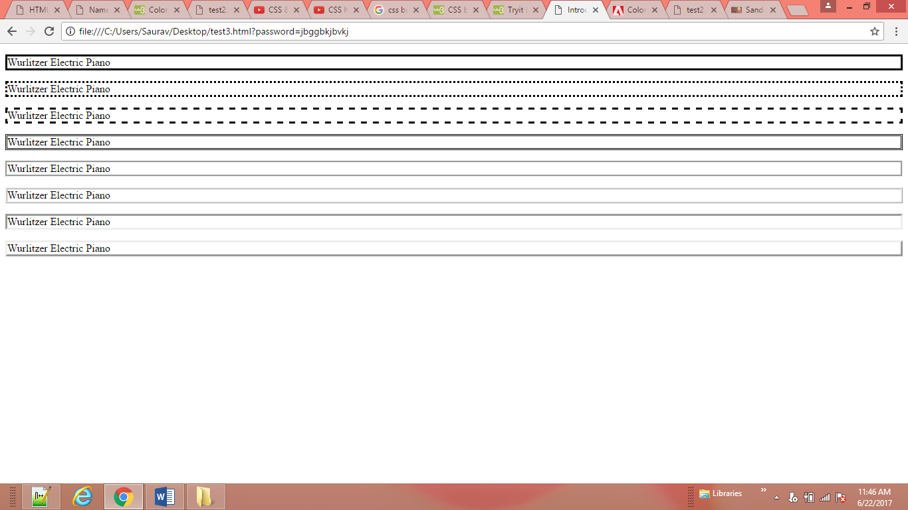

<body>

<p class="one">The ARP Odyssey was introduced in

1972.</p>

<p class="two">The ARP Odyssey was introduced in

1972.</p>

</body>

**CSS**

p.one { border-style:solid;

border-color: #0088dd;}

p.two { border-style: solid;

border-color: #bbbbaa #111111 #ee3e80 #0088dd;}

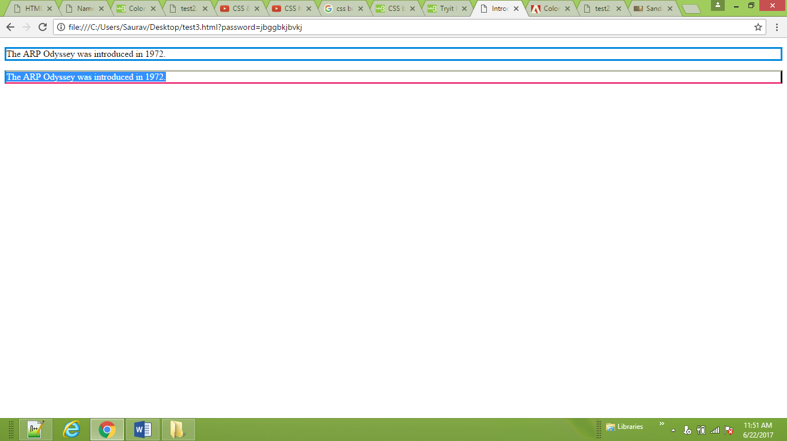

<body>

<p>Here is a simple chord sequence played on a

Hammond organ through a Leslie speaker.</p>

</body>

**CSS**

**p {**

**width: 250px;**

**border: 3px dotted #0088dd;}**

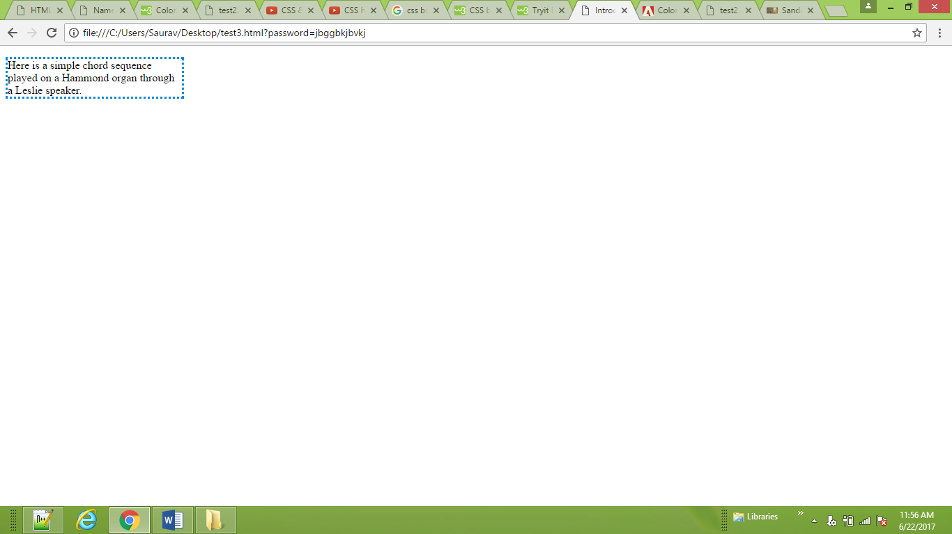

**<body>**

<p>Analog synths produce a wave sound, whereas the

sounds stored on a digital synth have been

sampled and then turned into numbers.</p>

<p class="example">Analog synths produce a wave

sound, whereas the sounds stored on a digital

synth have been sampled and then ... </p>

**</body>**

**CSS**

p {

width: 275px;

border: 2px solid #0088dd;}

p.example {

padding: 10px;}

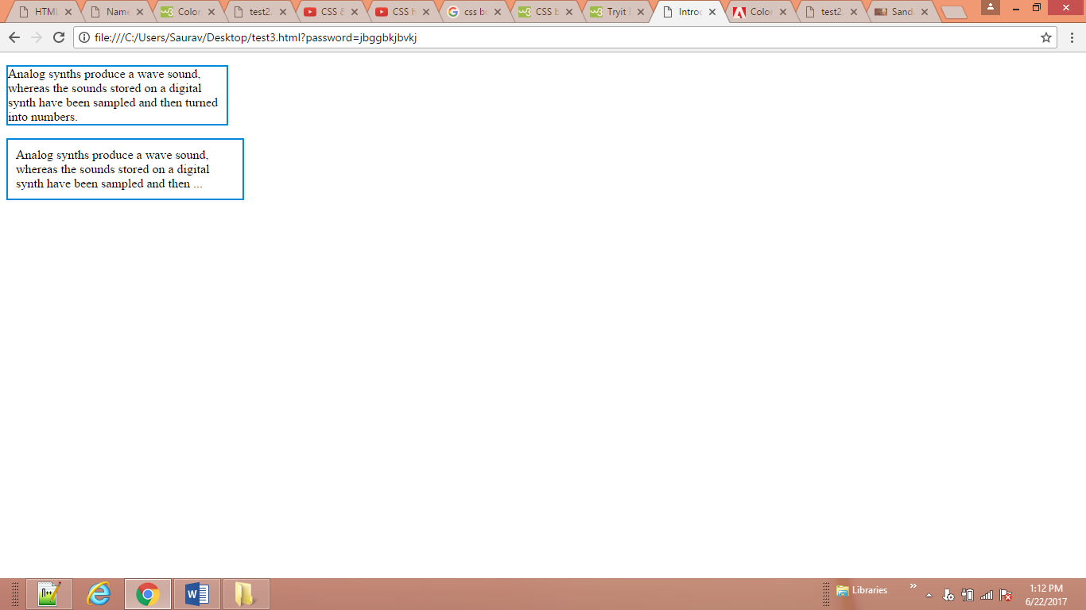

<body>

<p>Analog synthesizers are often said to have a

"warmer" sound than their digital counterparts.

</p>

<p class="example">Analog synthesizers are often

said to have a "warmer" sound than their digital

counterparts.</p>

</body>

CSS

p {

width: 200px;

border: 2px solid #0088dd;

padding: 10px;}

p.example {

margin: 20px;}

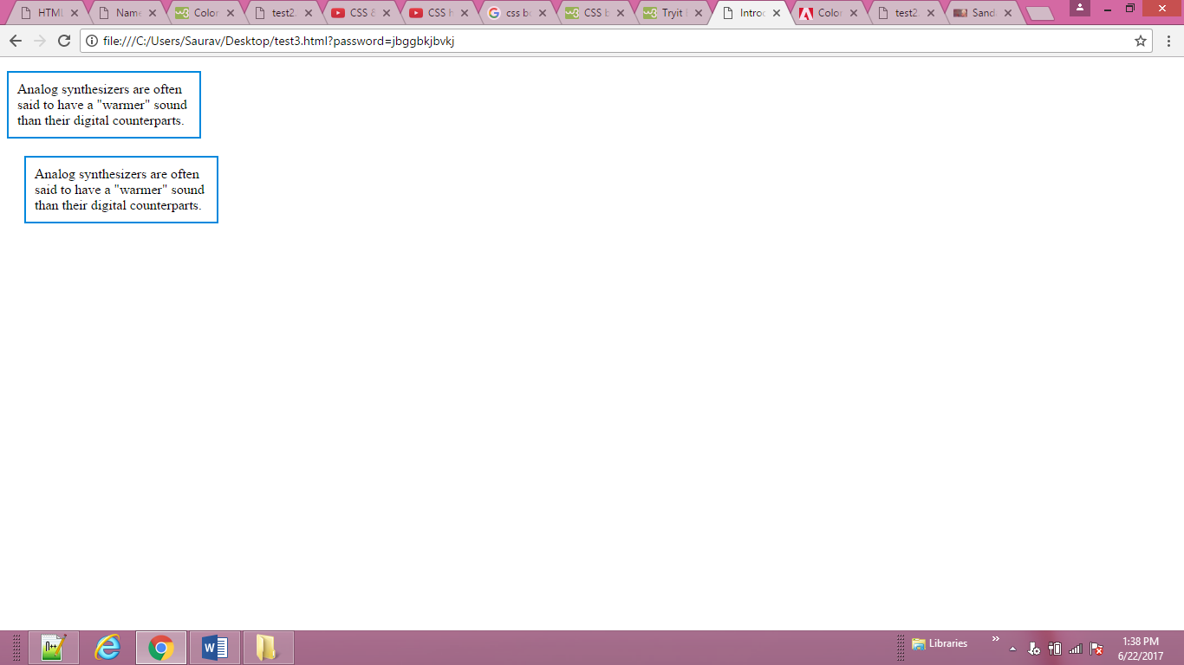

<body>

<p>Analog synthesizers are often said to have a

"warmer" sound than their digital

counterparts.</p>

<p class="example">Analog synthesizers are often

said to have a "warmer" sound than their

digital counterparts.</p>

</body>

**CSS**

**body {**

**text-align: center;}**

**p {**

**width: 300px;**

**padding: 50px;**

**border: 20px solid #0088dd;}**

**p.example {**

**margin: 10px auto 10px auto;**

**text-align: left;}**

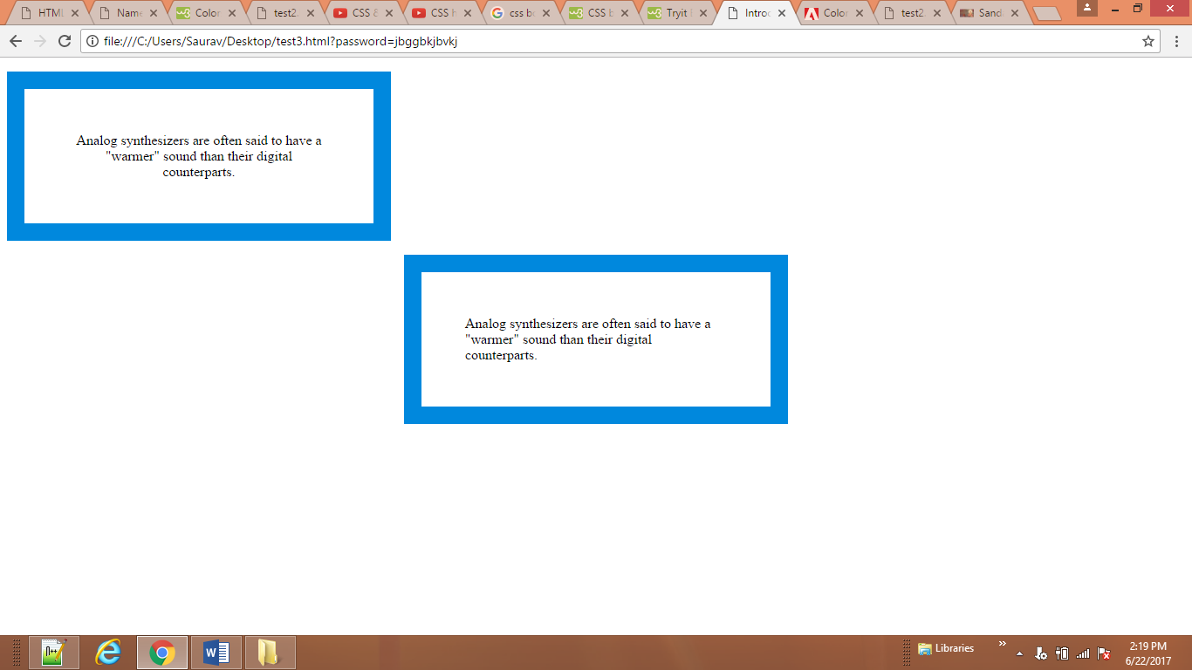

<body>

<ul>

<li>Home</li>

<li>Products</li>

<li class="coming-soon">Services</li>

<li>About</li>

<li>Contact</li>

</ul>

</body>

**CSS**

li {

display: inline;

margin-right: 10px;}

li.coming-soon {

display: none;}

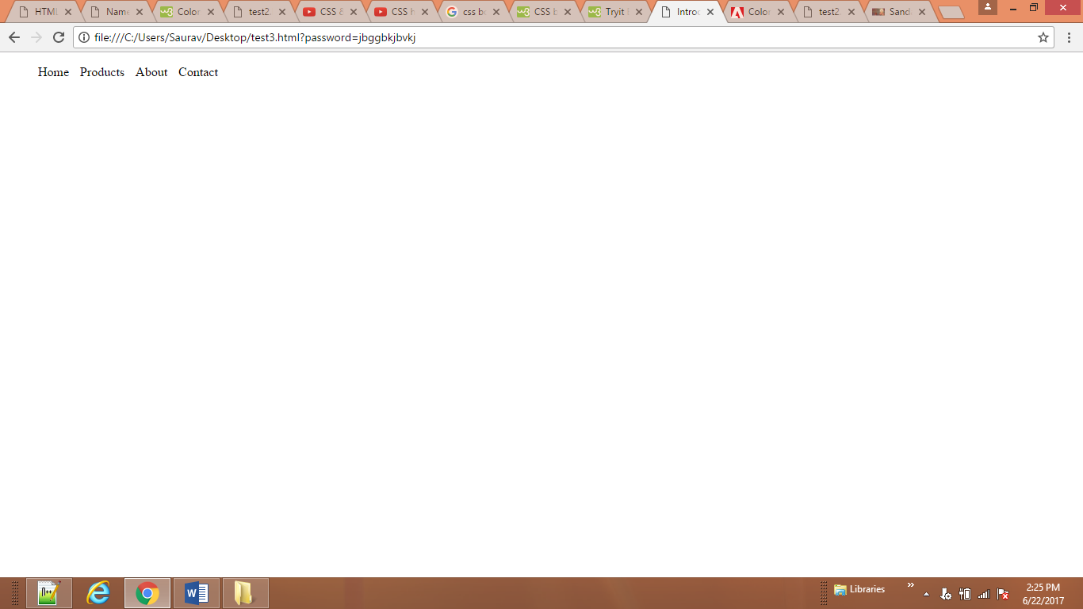

<body>

<ul>

<li>Home</li>

<li>Products</li>

<li class="coming-soon">Services</li>

<li>About</li>

<li>Contact</li>

</ul>

</body>

CSS

li {

display: inline;

margin-right: 10px;}

li.coming-soon {

visibility: hidden;}

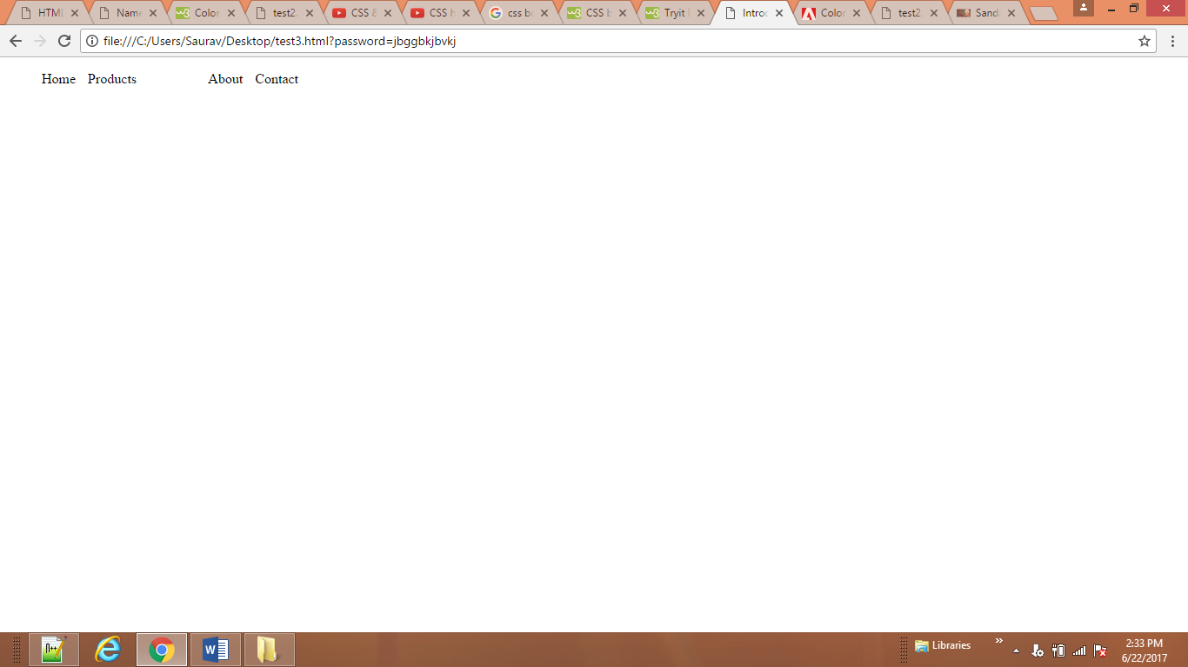

<body>

<p class="one"> This is sandarbh Kapur</p>

<p class="two"></p>

<p class="three"></p>

</body>

**CSS**

p.one {

border: 150px solid;

width: 150px;

border-image: url("ram/border1.jpg") 100 100 repeat;

margin:250px auto;

}

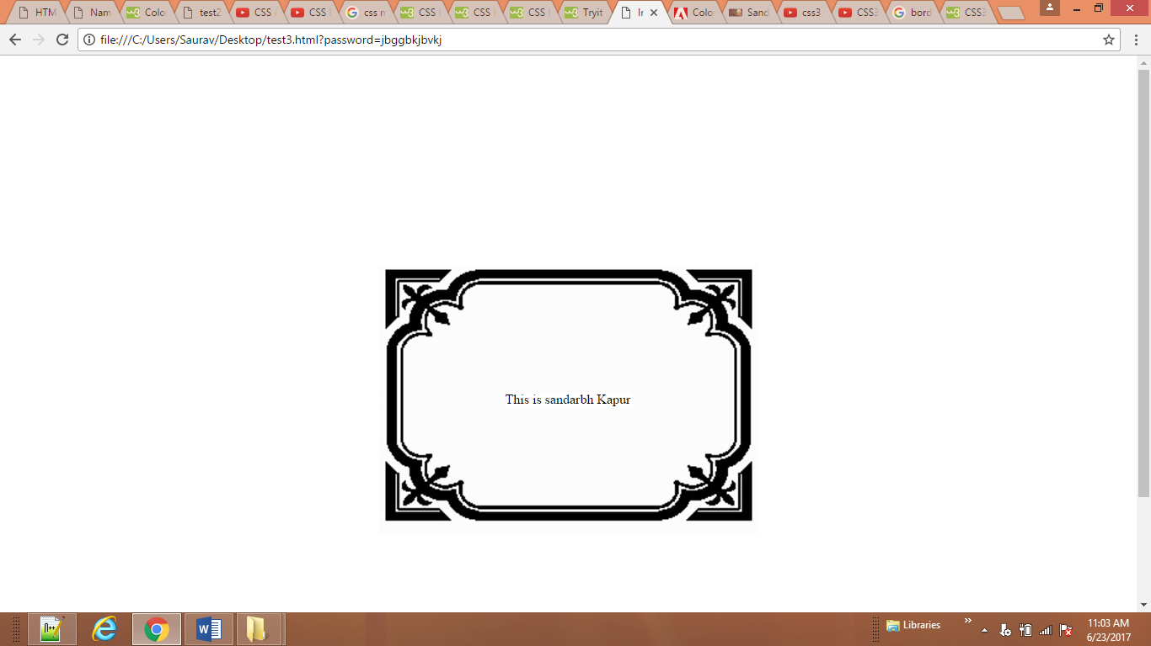

<body>

<p class="one"> This is sandarbh Kapur</p>

<p class="two"></p>

<p class="three"></p>

</body>

**CSS**

p.one {

border: 150px solid;

width: 150px;

border-image: url("ram/border1.jpg") 100 100 repeat;

box-shadow: 10px 10px 5px #888;

-moz-box-shadow: 0 0 10px #777777;

-webkit-box-shadow: 0 0 10px #777777;

margin:250px auto;

}

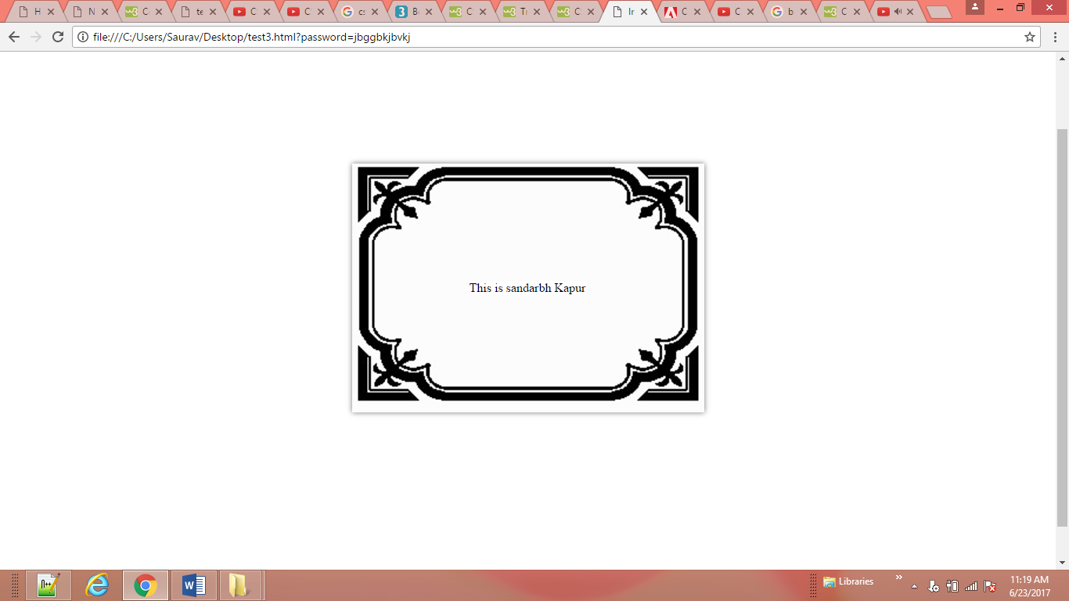

<body>

<p>Pet Sounds featured a number of unconventional

instruments such as bicycle bells, buzzing

organs, harpsichords, flutes, Electro-Theremin,

dog whistles, trains, Hawaiian-sounding string

instruments, Coca-Cola cans and barking dogs.</p>

</body>

**CSS**

p {

border: 5px solid #cccccc;

padding: 20px;

width: 275px;

text-align: center;

margin: 250px auto;

border-radius: 10px;

-moz-border-radius: 10px;

-webkit-border-radius: 10px;}

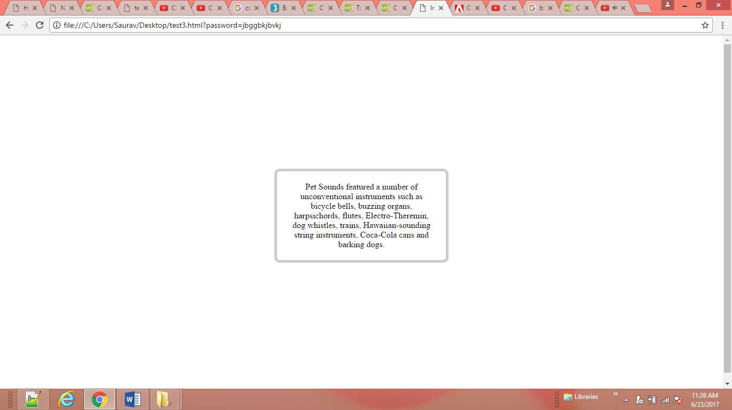

</head>

<body>

<div><p>Pet Sounds featured a number of unconventional

instruments such as bicycle bells, buzzing

organs, harpsichords, flutes, Electro-Theremin,

dog whistles, trains, Hawaiian-sounding string

instruments, Coca-Cola cans and barking dogs.</p></div>

</body>

**CSS**

div {

margin: 250px auto;

padding:25px 40px 5px;

width: 250px;

height: 175px;

background: #fc2e5a;

-moz-border-radius: 150px;

-webkit-border-radius: 150px;

border-radius: 150px;}

p{ margin-bottom: 50px 200px;

}

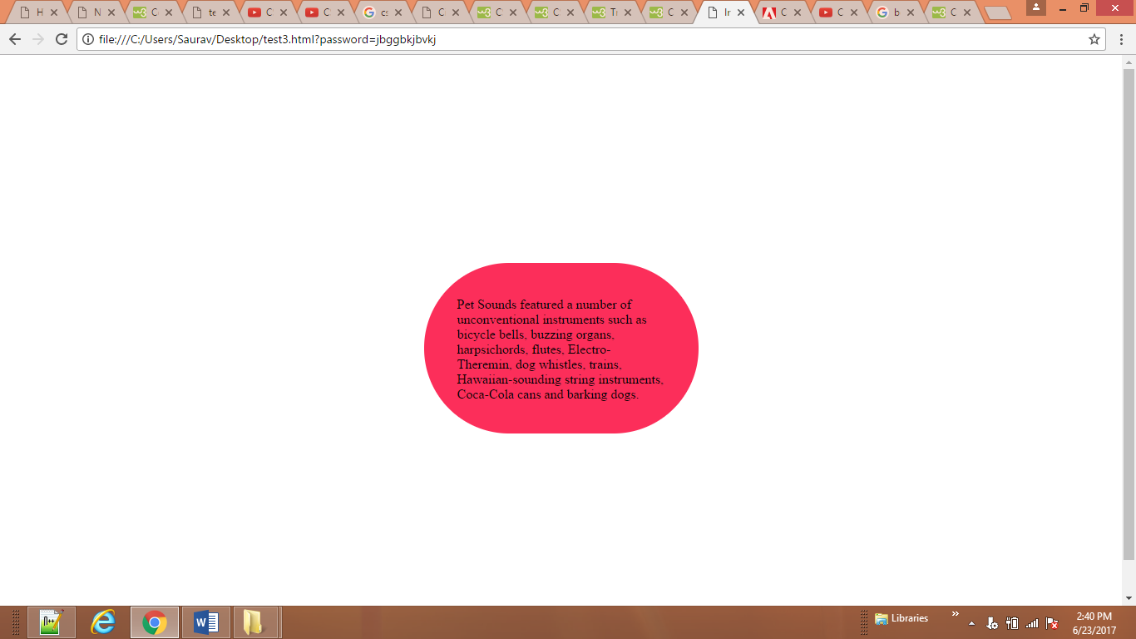

<body>

<h1>The Complete Poems</h1>

<h2>Emily Dickinson</h2>

<ol>

<li>Life</li>

<li>Nature</li>

<li>Love</li>

<li>Time and Eternity</li>

<li>The Single Hound</li>

</ol>

</body>

**CSS**

ol {

list-style-type: upper-alpha;}

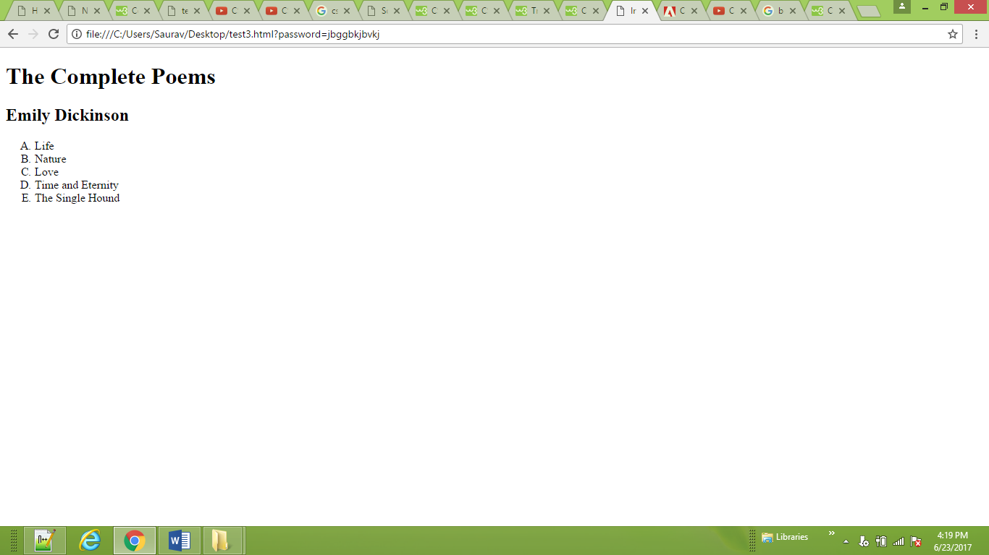

Check the page – 333

<body>

<h1>The Complete Poems</h1>

<h2>Emily Dickinson</h2>

<ul>

<li>Life</li>

<li>Nature</li>

<li>Love</li>

<li>Time and Eternity</li>

<li>The Single Hound</li>

</ul>

</body>

**CSS**

**ul {**

**list-style-image: url("ram/star2.gif");**

**width:1px;**

**height:1px;}**

**li {**

**margin: 10px 0px 0px 0px;}**

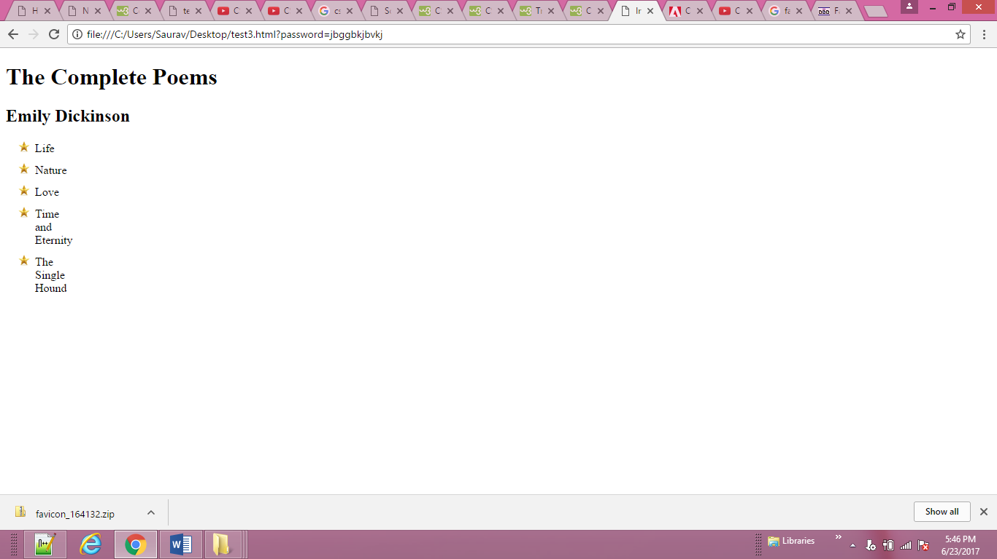

<body>

<ul class="illuminations">

<li>That idol, black eyes and ...</li>

<li>Gracious son of Pan! ...</li>

<li>When the world is reduced ...</li>

</ul>

<ul class="season">

<li>Once, if my memory serves ...</li>

<li>Hadn't I once a youth ...</li>

<li>Autumn already! ...</li>

</ul>

</body>

**CSS**

ul {width: 150px;}

li {margin: 10px;}

ul.illuminations {list-style-position: outside;}

ul.season {list-style-position: inside;}

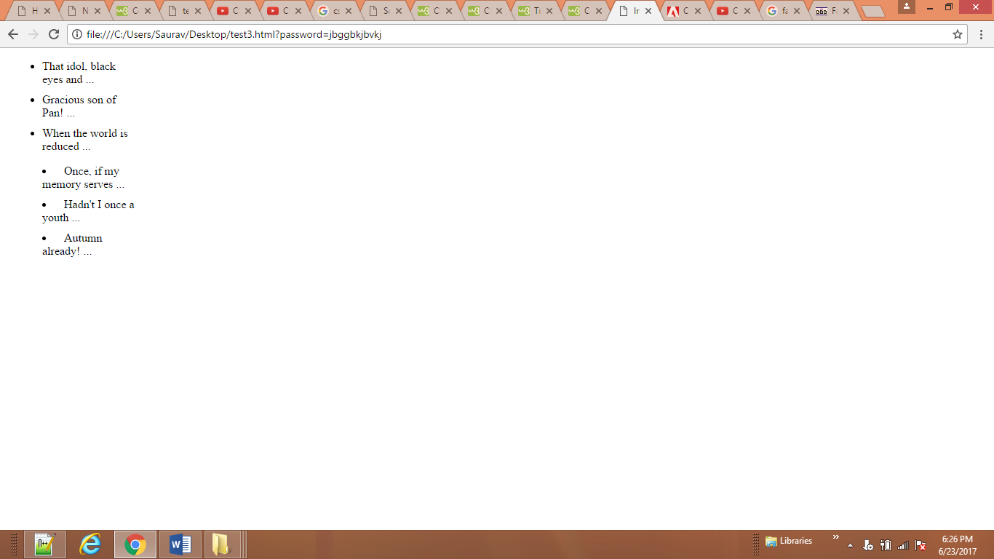

<body>

<h1>Quotes from Edgar Allan Poe</h1>

<ul>

<li> I have great faith in fools; self-confidence

my friends call it.</li>

<li>All that we see or seem is but a dream within

a dream.</li>

<li>I would define, in brief, the poetry of words

as the rhythmical creation of Beauty.</li>

</ul>

</body>

**CSS**

ul {

list-style: inside circle;

width: 300px;}

li {

margin: 10px 0px 0px 0px;}

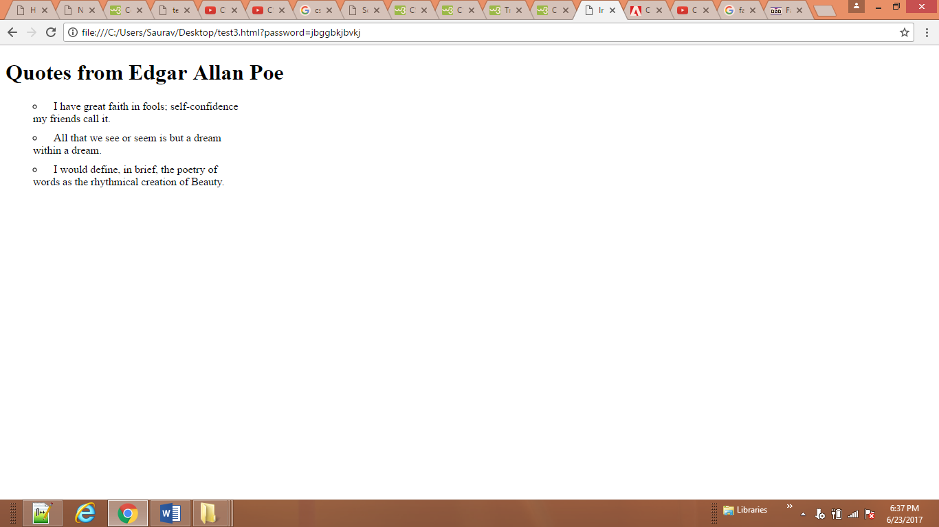

<body>

<h1>First Edition Auctions</h1>

<table>

<tr>

<th>Author</th>

<th>Title</th>

<th class="money">Reserve Price</th>

<th class="money">Current Bid</th>

</tr>

<tr>

<td>E.E. Cummings</td>

<td>Tulips & Chimneys</td>

<td class="money">$2,000.00</td>

<td class="money">$2,642.50</td>

</tr>

<tr class="even">

<td>Charles d'Orleans</td>

<td>Poemes</td>

<td class="money"></td>

<td class="money">$5,866.00</td>

</tr>

<tr>

<td>T.S. Eliot</td>

<td>Poems 1909 - 1925</td>

<td class="money">$1,250.00</td>

<td class="money">$8,499.35</td>

</tr>

<tr class="even">

<td>Sylvia Plath</td>

<td>The Colossus</td>

<td class="money"></td>

<td class="money">$1031.72</td>

</tr>

</table>

</body>

**CSS**

**body {**

**font-family: Arial, Verdana, sans-serif;**

**color: #111111;}**

**table {**

**width: 600px;}**

**th, td {**

**padding: 7px 10px 10px 10px;}**

**th {**

**text-transform: uppercase;**

**letter-spacing: 0.1em;**

**font-size: 90%;**

**border-bottom: 2px solid #111111;**

**border-top: 1px solid #999;**

**text-align: left;}**

**tr.even {**

**background-color: #efefef;}**

**tr:hover {**

**background-color: #c3e6e5;}**

**.money {**

**text-align: right;}**

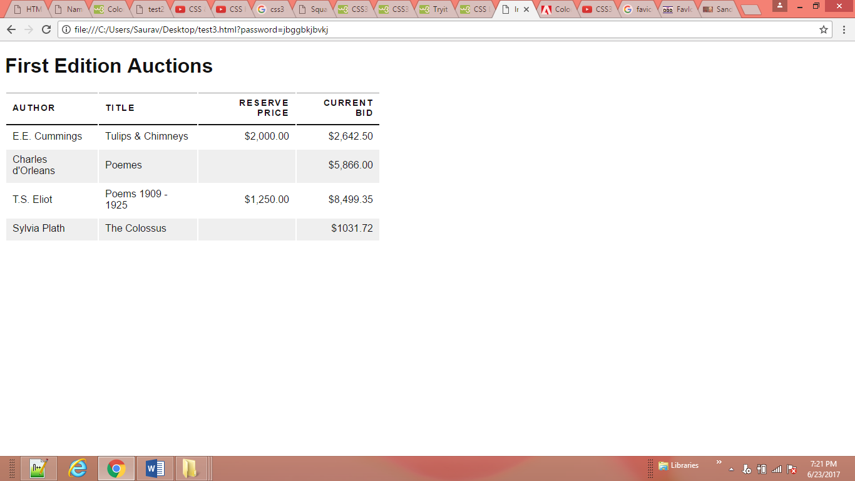

body>

<table class="one">

<tr>

<td>1</td>

<td>2</td>

</tr>

<tr>

<td>3</td>

<td></td>

</tr>

</table>

<br><br><br><br><br>

<table class="one">

<tr>

<td>1</td>

<td>2</td>

</tr>

<tr>

<td>3</td>

<td></td>

</tr>

</table>

</body>

**CSS**

td {

border: 1px solid #0088dd;

padding: 15px;}

table.one {

empty-cells: show;}

table.two {

empty-cells: hide;}

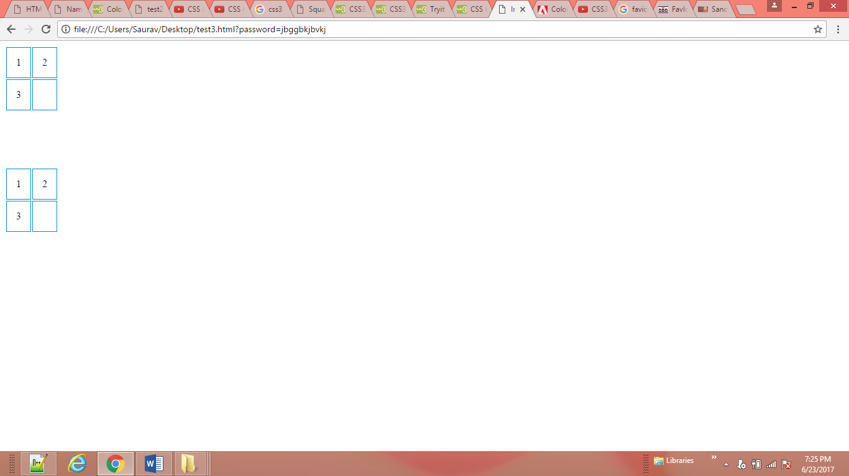

body>

<table class="one">

<tr>

<td>1</td>

<td>2</td>

</tr>

<tr>

<td>3</td>

<td></td>

</tr>

</table>

<br><br><br><br><br>

<table class="one">

<tr>

<td>1</td>

<td>2</td>

</tr>

<tr>

<td>3</td>

<td></td>

</tr>

</table>

</body>

**CSS**

td {

background-color: #0088dd;

padding: 15px;

border: 2px solid #000000;}

table.one {

border-spacing: 5px 15px;}

table.two {

border-collapse: collapse;}

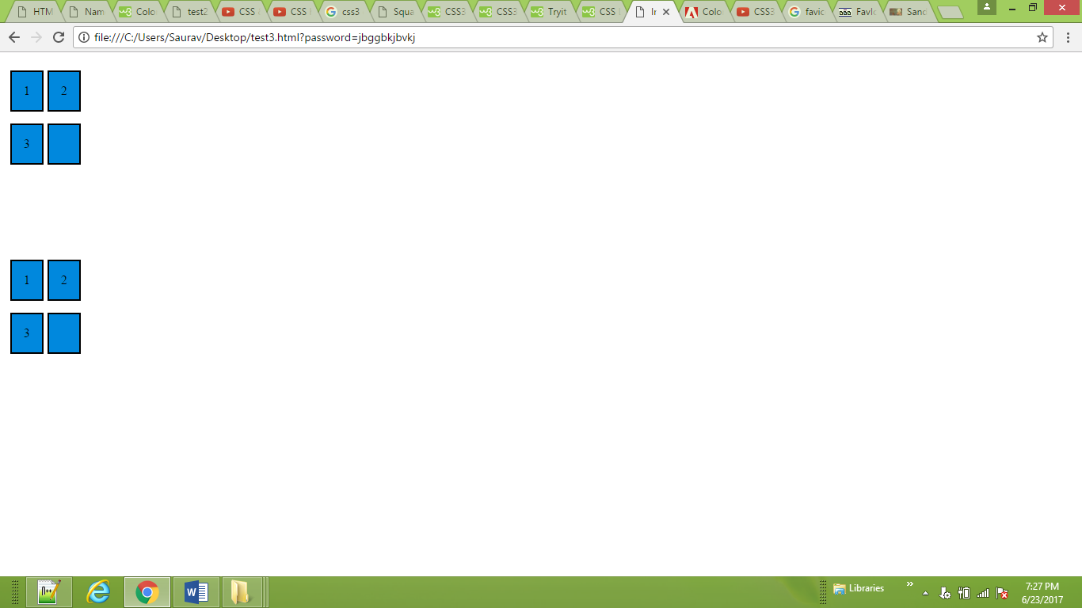

<body>

<form>

<fieldset>

<legend> YOUR PERSONAL INFORMATION </legend>

USER NAME:

<input type="text" name="name"><br><br>

PASSWORD:

<input type="password" name="name"><br><br>

<input type= "radio" name="sex" value="Male"> Male

<input type= "radio" name="sex" value="Female"> Female<br><br>

<input type= "checkbox" name="sex" value="Female">HTML

<input type= "checkbox" name="sex" value="Female">CSS

<input type= "checkbox" name="sex" value="Female">PHP

<input type= "checkbox" name="sex" value="Female">BOOTSTRAP<br><br>

<textarea name="comment" rows="10" cols="36"> Some text... </textarea> <br><br>

<select name="select">

<option> </option>

<option> HTML </option>

<option> CSS </option>

<option> PHP </option>

<option> JAVA </option>

</select><br><br>

<input type="Submit" value="Login" >

<input type="Submit" value="Submit" >

<button type="Reset"> Reset</button>

</fieldset>

</form>

</body>

**CSS**

input {

font-size: 80%;

color: #5a5854;

background-color: #f2f2f2;

border: 1px solid #bdbdbd;

border-radius: 5px;

padding: 5px 5px 5px 30px;

background-repeat: no-repeat;

background-position: 8px 9px;

margin-bottom: 10px;}

input:focus {

background-color: #ffffff;

border: 1px solid #b1e1e4;}

input[type=text] {

box-sizing: border-box;

border: 2px solid #ccc;

border-radius: 4px;

font-size: 16px;

background-color: white;

background-image: url("ram/email.ico");

background-position: 10px 10px;

background-repeat: no-repeat;

padding: 12px 20px 12px 40px;

}

input[type=password] {

box-sizing: border-box;

border: 2px solid #ccc;

border-radius: 4px;

font-size: 16px;

background-color: white;

background-image: url("ram/email.ico");

background-position: 10px 10px;

background-repeat: no-repeat;

padding: 12px 20px 12px 40px;

}

input[type=submit] {

color: #444444;

text-shadow: 0px 1px 1px #ffffff;

border-bottom: 2px solid #b2b2b2;

background-color: #b9e4e3;

background: -webkit-gradient(linear, left top,

left bottom, from(#beeae9), to(#a8cfce));

background:

-moz-linear-gradient(top, #beeae9, #a8cfce);

background:

-o-linear-gradient(top, #beeae9, #a8cfce);

background:

-ms-linear-gradient(top, #beeae9, #a8cfce);}

input[type=submit]:hover {

color: #333333;

border: 1px solid #a4a4a4;

border-top: 2px solid #b2b2b2;

background-color: #a0dbc4;

background: -webkit-gradient(linear, left top,

left bottom, from(#a8cfce), to(#beeae9));

background:

-moz-linear-gradient(top, #a8cfce, #beeae9);

background:

-o-linear-gradient(top, #a8cfce, #beeae9);

background:

-ms-linear-gradient(top, #a8cfce, #beeae9);}

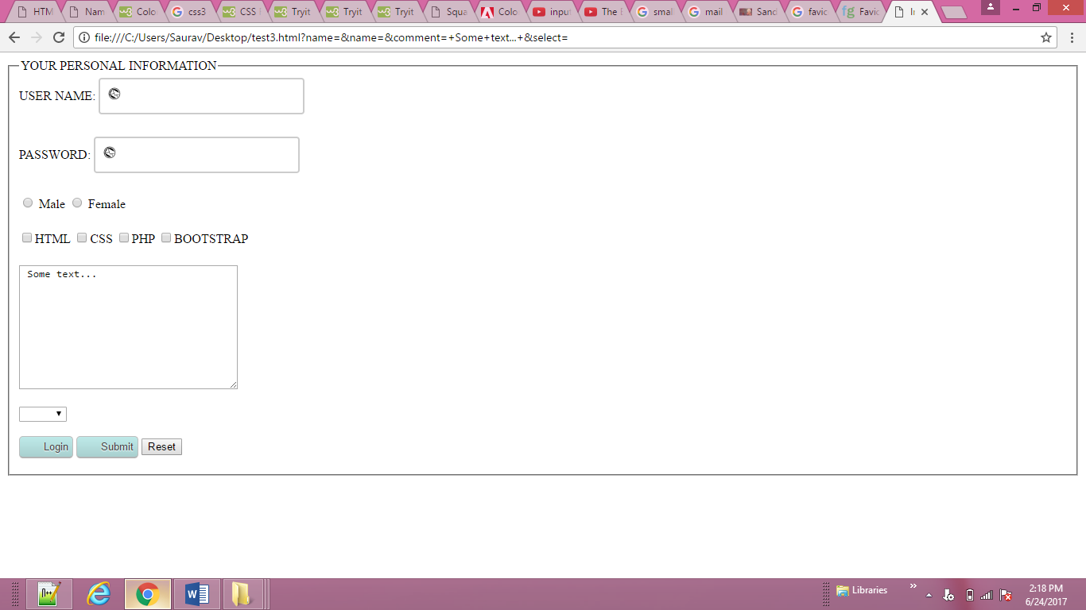

<body>

<form>

<fieldset>

<legend> YOUR PERSONAL INFORMATION </legend>

USER NAME:

<input type="text" name="name"><br><br>

PASSWORD:

<input type="password" name="name"><br><br>

<input type= "radio" name="sex" value="Male"> Male

<input type= "radio" name="sex" value="Female"> Female<br><br>

<input type= "checkbox" name="sex" value="Female">HTML

<input type= "checkbox" name="sex" value="Female">CSS

<input type= "checkbox" name="sex" value="Female">PHP

<input type= "checkbox" name="sex" value="Female">BOOTSTRAP<br><br>

<textarea name="comment" rows="10" cols="36"> Some text... </textarea> <br><br>

<select name="select">

<option> </option>

<option> HTML </option>

<option> CSS </option>

<option> PHP </option>

<option> JAVA </option>

</select><br><br>

<input type="Submit" value="Login" >

<input type="Submit" value="Submit" >

<button type="Reset"> Reset</button>

</fieldset>

</form>

</body>

**Move the form to right or left**

**CSS**

fieldset {

margin-left:auto;

width: 350px;

border: 1px solid #dcdcdc;

border-radius: 10px;

padding: 20px;

text-align: left;}

legend {

background-color: #efefef;

border: 1px solid #dcdcdc;

border-radius: 10px;

padding: 10px 20px;

text-align: left;

text-transform: uppercase;}

<body>

<form action="example.php" method="post">

<div>

<label for="name" class="title">Name:</label>

<input type="text" id="name" name="name" />

</div>

<div>

<label for="email" class="title">Email:</label>

<input type="email" id="email" name="email" />

</div>

<div>

<span class="title">Gender:</span>

<input type="radio" name="gender" id="male"

value="M" />

<label for="male">Male</label>

<input type="radio" name="gender" id="female"

value="F" />

<label for="female">Female</label><br />

</div>

<div>

<input type="submit" value="Register"

id="submit" />

</div>

</form>

</body>

**CSS**

div {

border-bottom: 1px solid #efefef;

margin: 10px;

padding-bottom: 10px;

width: 260px;}

.title {

float: left;

width: 100px;

text-align: right;

padding-right: 10px;}

.radio-buttons label {

float: none;}

.submit {

text-align: right;}

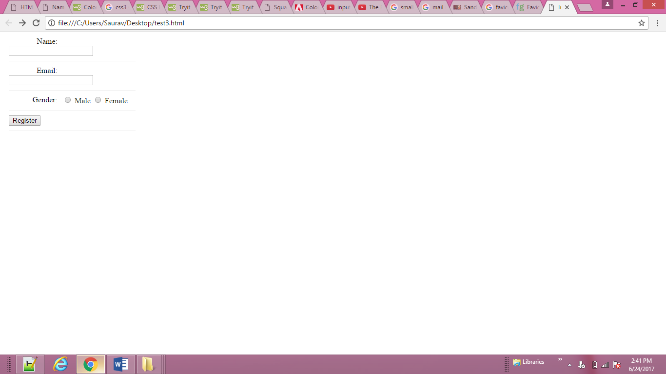

<body>

<a href="http://www.whitmanarchive.org">

Walt Whitman</a>

</body>

**CSS**

a {

cursor: auto;}

**Different example of Cursor:**

auto |crosshair| default | pointer | move | text | wait | help | url("cursor.gif");



<body>

<body>

<h1>The Evolution of the Bicycle</h1>

<p>In 1817 Baron von Drais invented a walking

machine that would help him get around the

royal gardens faster...</p>

</body>

</body>

**CSS**

body {

width: 750px;

font-family: Arial, Verdana, sans-serif;

color: #665544;}

h1 {

background-color: #efefef;

padding: 10px;}

p {

width: 450px;}

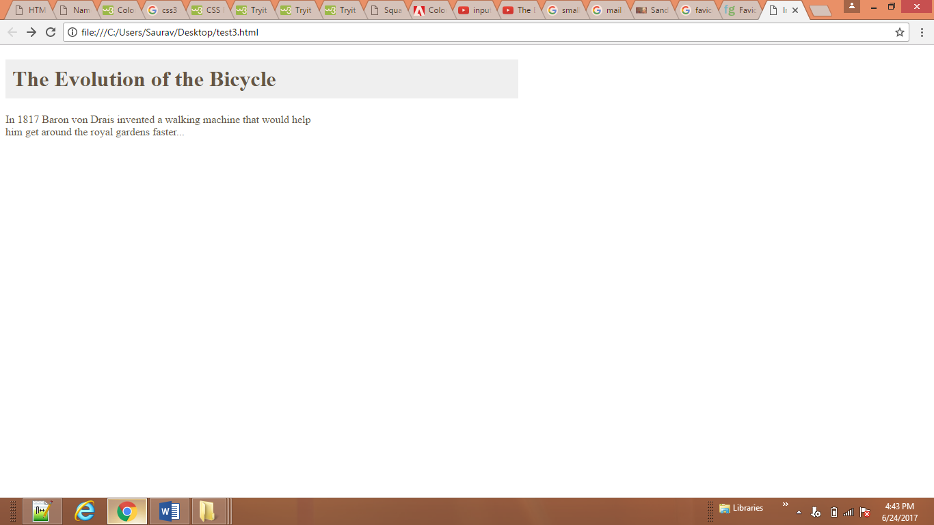

<body>

<h2 class="one">This is a heading with no position</h2>

<h2 class="pos_left">This heading is moved left according to its normal position</h2>

<h2 class="pos_right">This heading is moved right according to its normal position</h2>

<p>Relative positioning moves an element RELATIVE to its original position.</p>

<p>The style "left:-20px" subtracts 20 pixels from the element's original left position.</p>

<p>The style "left:20px" adds 20 pixels to the element's original left position.</p>

</body>

**CSS**

**h2.pos_left {**

**position: relative;**

**left: -20px;}**

**h2.pos_right {**

**position: relative;**

**left: 20px;}**

**.one{position: relative;**

**top: 10px;**

**left: 100px;}**

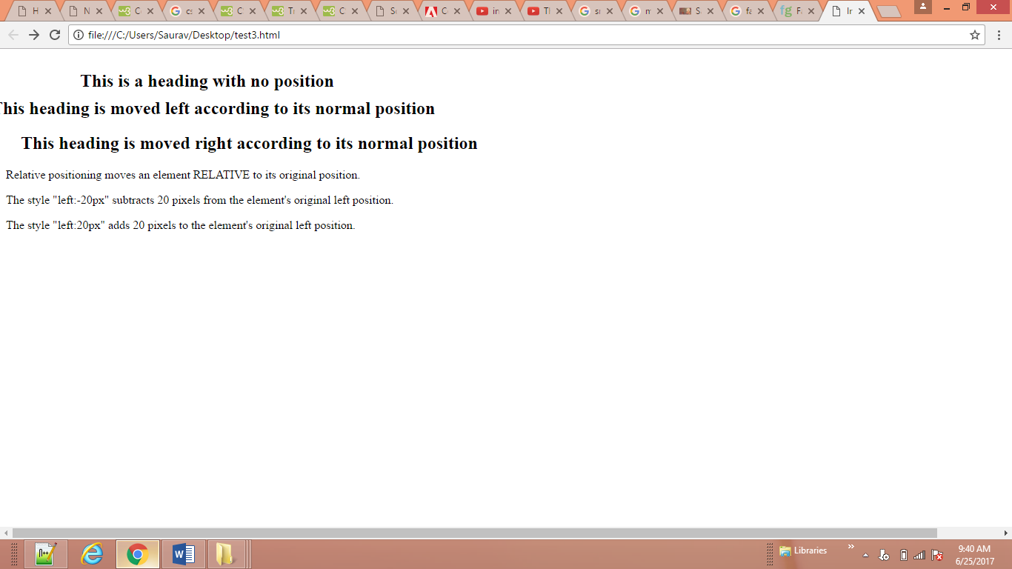

<body>

<h2>This is a heading with an absolute position</h2>

<p>With absolute positioning, an element can be placed anywhere on a page.

The heading below is placed 100px from the left of the page and 150px from the top of the page.</p>

<br><br><<br><br><br><br><br><br><br>

<h1>The Evolution of the Bicycle</h1>

<p class="one">In 1817 Baron von Drais invented a walking

machine that would help him get around the

royal gardens faster...</p>

</body>

**CSS**

h2 {position: absolute;

right: 100px;

top: 150px;}

h1 {position: absolute;

top: 0px;

left: 500px;

width: 250px;}

.one {width: 450px;}

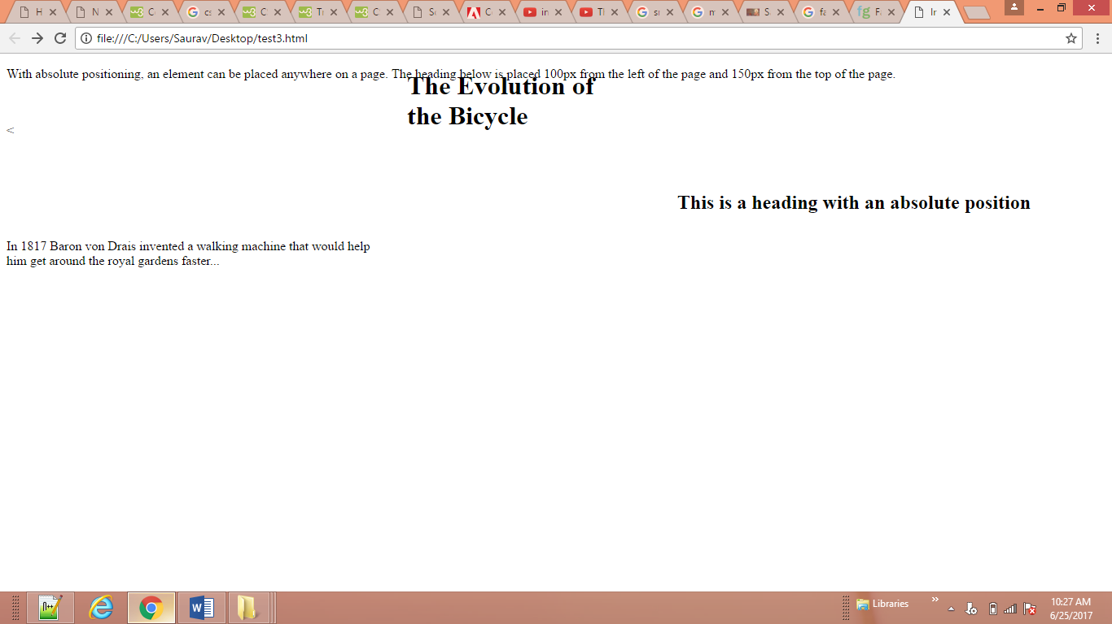

<body>

<h1>The Evolution of the Bicycle</h1>

<p class="example">In 1817 Baron von Drais

invented a walking machine that would help him

get around the royal gardens faster...</p>

</body>

**CSS**

h1 {

position: fixed;

top: 0px;

left: 50px;

padding: 10px;

margin: 0px;

width: 35%;

text-align:center;

background-color: #efefef;}

p.example {

margin-top: 100px;}

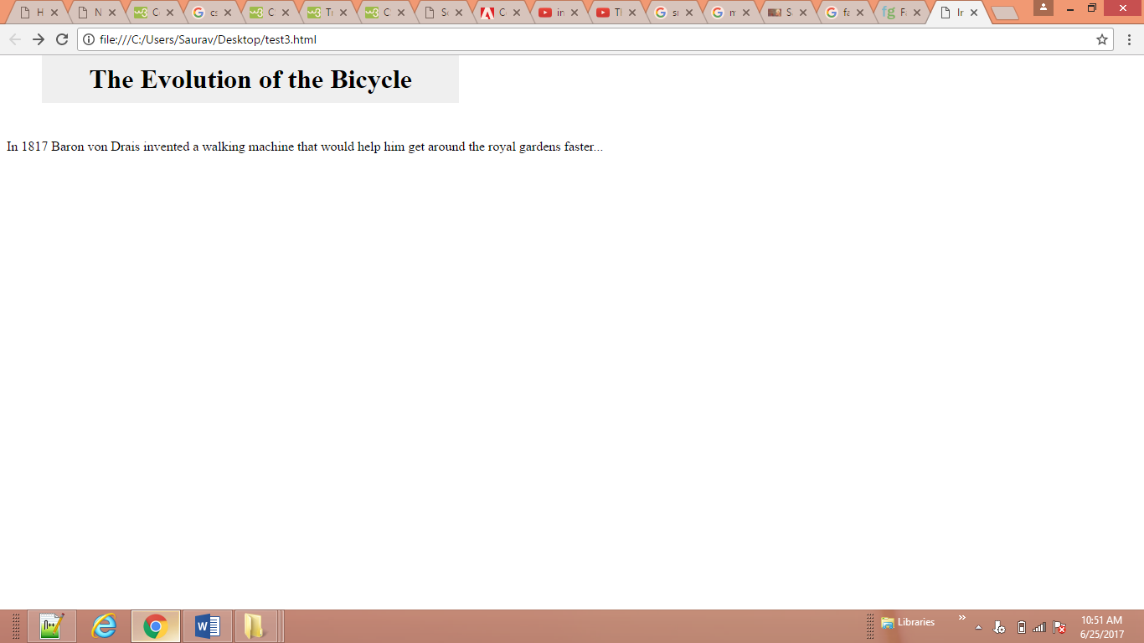

<body>

<img src="ram/feild.jpg" alt="sandarbh">

<p>In 1817 Baron von Drais invented a walking machine that would help him get around the royal

gardens faster. In 1817 Baron von Drais invented a walking machine that would help him

get around the royal gardens faster... In 1817 Baron von Drais invented a walking machine that would

help him get around the royal gardens faster... In 1817 Baron von Drais invented a walking machine that

would help him get around the royal gardens faster... </p>

</body>

**CSS**

img {width:250px;

height:250px;

position: fixed;

top: 0px;

left: 0px;

margin: 0px;

padding: 10px;

z-index: -90;}

p {position: relative;

top: 0px;

left: 70px;}

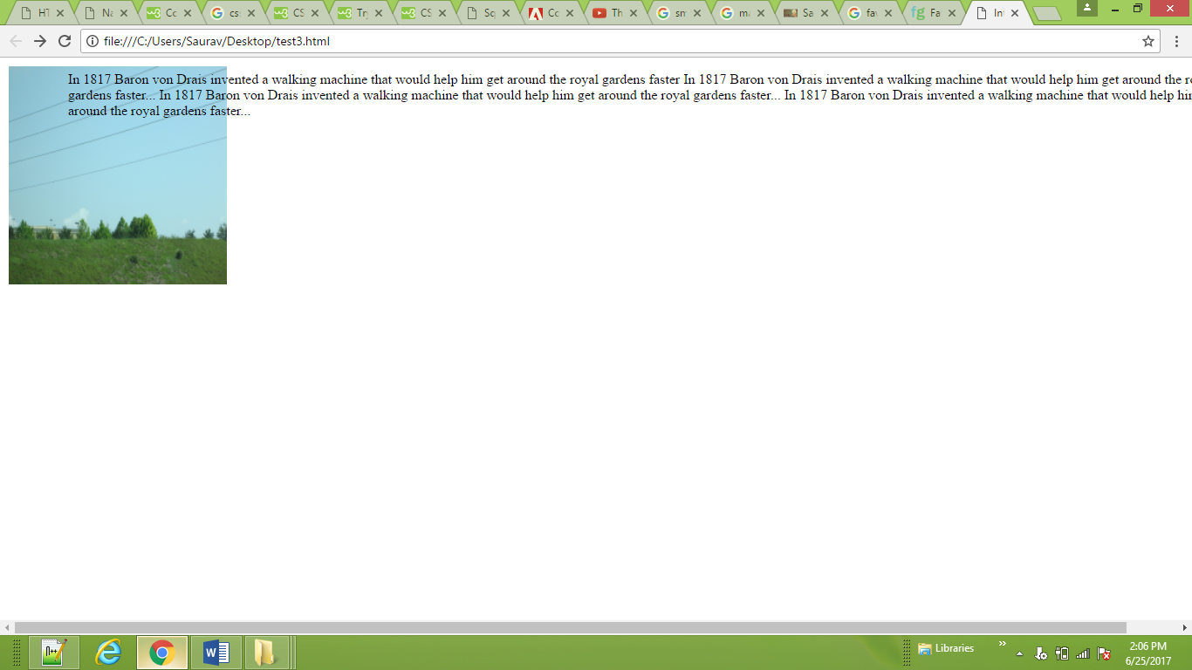

<body>

<h1>The Evolution of the Bicycle</h1>

<blockquote>"Life is like riding a bicycle. To keep your balance you must keep moving." - Albert Einstein</blockquote>

<p>In 1817 Baron von Drais invented a walking machine that would help him get around the royal

gardens faster: two same-size in-line wheels, the front one steerable, mounted in a frame ... In 1817

Baron von Drais invented a walking machine that would help him get around the royal gardens faster:

two same-size in-line wheels, the front one steerable, mounted in a frame ... In 1817 Baron von Drais

invented a walking machine that would help him get around the royal gardens faster: two same-size in-

line wheels, the front one steerable, mounted in a frame ... </p>

</body>

**CSS**

blockquote { float: right;

width: 275px;

font-size: 130%;

font-style: italic;

font-family: Georgia, Times, serif;

margin: 0px 0px 10px 10px;

padding: 10px;

border-top: 1px solid #665544;

border-bottom: 1px solid #665544;}

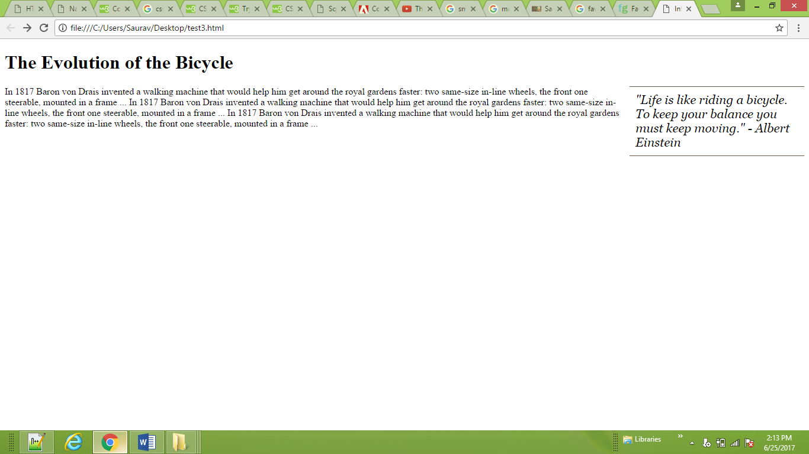

<body>

<h1>The Evolution of the Bicycle</h1>

<p>In 1817 Baron von Drais invented a walking machine that would help him get around the royal

gardens faster: two same-size in-line wheels, the front one steerable, mounted in a frame ...

In 1817 Baron von Drais invented a walking machine that would help him get around the royal

gardens faster: two same-size in-line wheels, the front one steerable, mounted in a frame ...

In 1817 Baron von Drais invented a walkin machine that would help him get around the royal

gardens faster: two same-size in-line wheels, the front one steerable, mounted in a frame ... </p>

p>In 1817 Baron von Drais invented a walking machine that would help him get around the royal

gardens faster: two same-size in-line wheels, the front one steerable, mounted in a frame ...

In 1817 Baron von Drais invented a walking machine that would help him get around the royal

gardens faster: two same-size in-line wheels, the front one steerable, mounted in a frame ...

In 1817 Baron von Drais invented a walkin machine that would help him get around the royal

gardens faster: two same-size in-line wheels, the front one steerable, mounted in a frame ... </p>

p>In 1817 Baron von Drais invented a walking machine that would help him get around the royal

gardens faster: two same-size in-line wheels, the front one steerable, mounted in a frame ...

In 1817 Baron von Drais invented a walking machine that would help him get around the royal

gardens faster: two same-size in-line wheels, the front one steerable, mounted in a frame ...

In 1817 Baron von Drais invented a walkin machine that would help him get around the royal

gardens faster: two same-size in-line wheels, the front one steerable, mounted in a frame ... </p>

p>In 1817 Baron von Drais invented a walking machine that would help him get around the royal

gardens faster: two same-size in-line wheels, the front one steerable, mounted in a frame ...

In 1817 Baron von Drais invented a walking machine that would help him get around the royal

gardens faster: two same-size in-line wheels, the front one steerable, mounted in a frame ...

In 1817 Baron von Drais invented a walkin machine that would help him get around the royal

gardens faster: two same-size in-line wheels, the front one steerable, mounted in a frame ... </p>

</body>

**CSS**

body {

width: 940px;

font-family: Arial, Verdana, sans-serif;

color: #665544;}

p {

width: 215px;

float: left;

margin: 5px;

padding: 5px;

background-color: #efefef;}

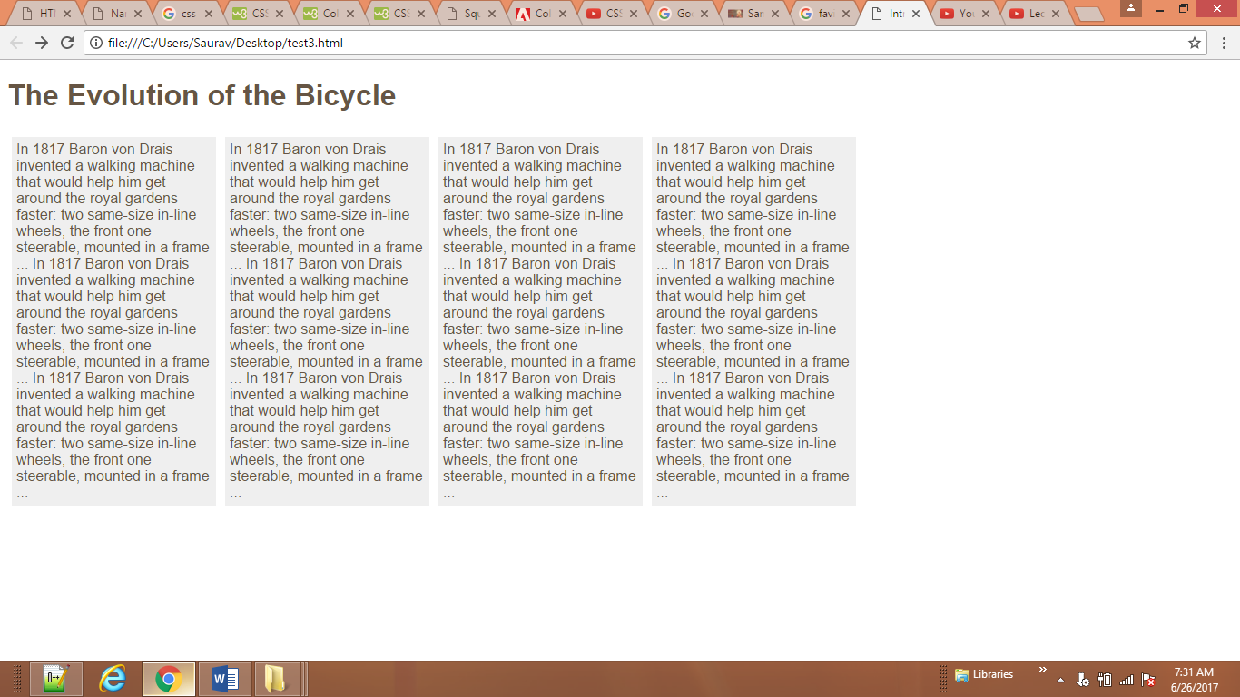

<body>

<p class="clear">In 1817 Baron von Drais invented a walking

machine that would help him get around the royal

gardens faster: two same-size in-line wheels, the

front one steerable, mounted in a frame ...

In 1817 Baron von Drais invented a walking

machine that would help him get around the royal

gardens faster: two same-size in-line wheels, the

front one steerable, mounted in a frame ...

In 1817 Baron von Drais invented a walking

machine that would help him get around the royal

gardens faster: two same-size in-line wheels, the

front one steerable, mounted in a frame ... </p>

<p class="clear">In 1817 Baron von Drais invented a walking

machine that would help him get around the royal

gardens faster: two same-size in-line wheels, the

front one steerable, mounted in a frame ...

In 1817 Baron von Drais invented a walking

machine that would help him get around the royal

gardens faster: two same-size in-line wheels, the

front one steerable, mounted in a frame ...

In 1817 Baron von Drais invented a walking

machine that would help him get around the royal

gardens faster: two same-size in-line wheels, the

front one steerable, mounted in a frame ... </p>

<p class="clear">In 1817 Baron von Drais invented a walking

machine that would help him get around the royal

gardens faster: two same-size in-line wheels, the

front one steerable, mounted in a frame ...

In 1817 Baron von Drais invented a walking

machine that would help him get around the royal

gardens faster: two same-size in-line wheels, the

front one steerable, mounted in a frame ...

In 1817 Baron von Drais invented a walking

machine that would help him get around the royal

gardens faster: two same-size in-line wheels, the

front one steerable, mounted in a frame ... </p>

<p class="clear">In 1817 Baron von Drais invented a walking

machine that would help him get around the royal

gardens faster: two same-size in-line wheels, the

front one steerable, mounted in a frame ...

In 1817 Baron von Drais invented a walking

machine that would help him get around the royal

gardens faster: two same-size in-line wheels, the

front one steerable, mounted in a frame ...

In 1817 Baron von Drais invented a walking

machine that would help him get around the royal

gardens faster: two same-size in-line wheels, the

front one steerable, mounted in a frame ... </p>

</body>

**CSS**

**body {**

**width: 750px;**

**font-family: Arial, Verdana, sans-serif;**

**color: #665544;}**

**p {**

**width: 230px;**

**float: left;**

**margin: 5px;**

**padding: 5px;**

**background-color: #efefef;}**

**.clear {**

**clear:both;}**

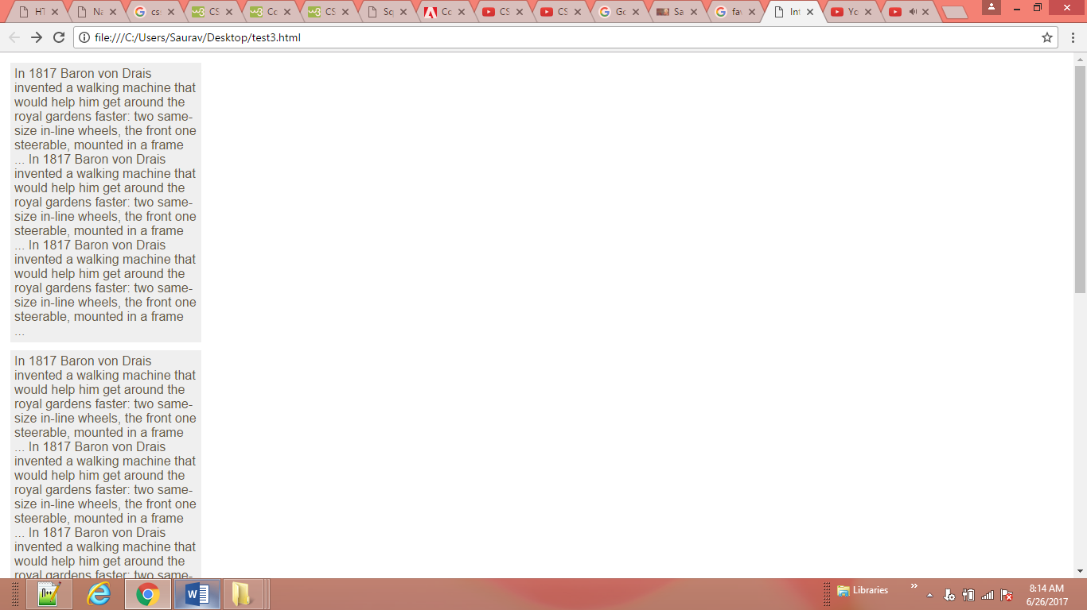

<body>

<h1>The Evolution of the Bicycle</h1>

<div class="one">

<p>In 1817 Baron von Drais invented a walking

machine that would help him get around the

royal gardens faster...</p>

</body>

**CSS**

.one {

border: 1px solid #665544;

overflow: auto;

width: 100%;}

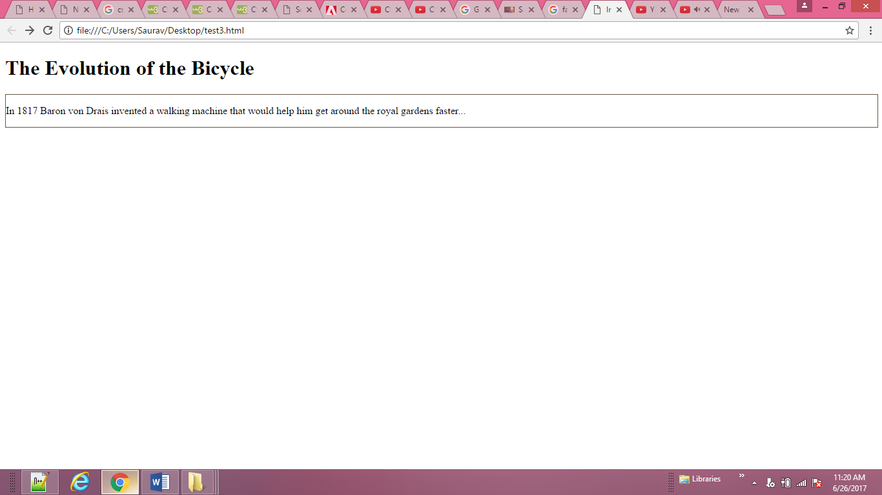

<body>

<h1>The Evolution of the Bicycle</h1>

<div class="column1of3">

<h3>The First Bicycle</h3>

<p>In 1817 Baron von Drais invented a walking machine that would help him get around the royal

frame ... </p> </div>

<div class="column2of3">

<h3>Further Innovations</h3>

<p>In 1817 Baron von Drais invented a walking e in-line wheels, the front one steerable, mounted in a

frame ...In 1817 Baron von Drais invented a walking machine that would help him get around the

royal gardens faster: two same-size in-line wheels, the front one steerable, mounted in a frame ...

</p> ...</div>

<div class="column3of3">

<h3>Bicycle Timeline</h3>

<p>In 1817 Baron von Drais invented a walking vented a walking machine that would help him get

around the royal gardens faster: two same-size in-line wheels, thefront one steerable, mounted in a

frame ... </p>.

</div

</body>

**CSS**

.column1of2 {

float: left;

width: 620px;

margin: 10px;}

.column2of2 {

float: left;

width: 300px;

margin: 10px;}

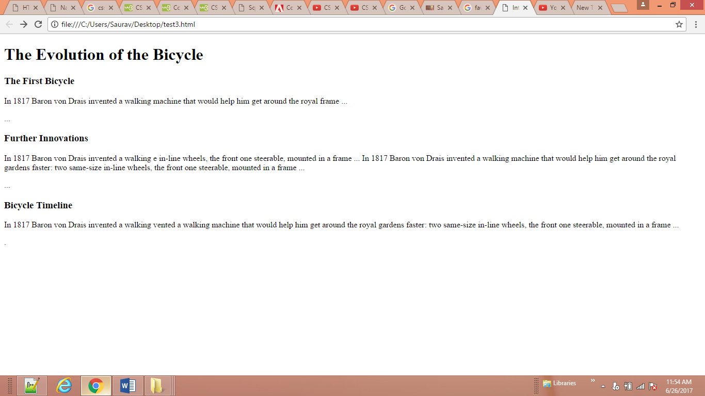

<body>

<h1>The Evolution of the Bicycle</h1>

<div class="column1of3">

<h3>The First Bicycle</h3>

<p>In 1817 Baron von Drais invented a walking machine that would help him get around the royal

frame ... </p> </div>

<div class="column2of3">

<h3>Further Innovations</h3>

<p>In 1817 Baron von Drais invented a walking e in-line wheels, the front one steerable, mounted in a

frame ...In 1817 Baron von Drais invented a walking machine that would help him get around the

royal gardens faster: two same-size in-line wheels, the front one steerable, mounted in a frame ...

</p> ...</div>

<div class="column3of3">

<h3>Bicycle Timeline</h3>

<p>In 1817 Baron von Drais invented a walking vented a walking machine that would help him get

around the royal gardens faster: two same-size in-line wheels, thefront one steerable, mounted in a

frame ... </p>.

</div

</body>

**CSS**

.column1of3, .column2of3, .column3of3 {

width: 300px;

float: left;

margin: 10px;}

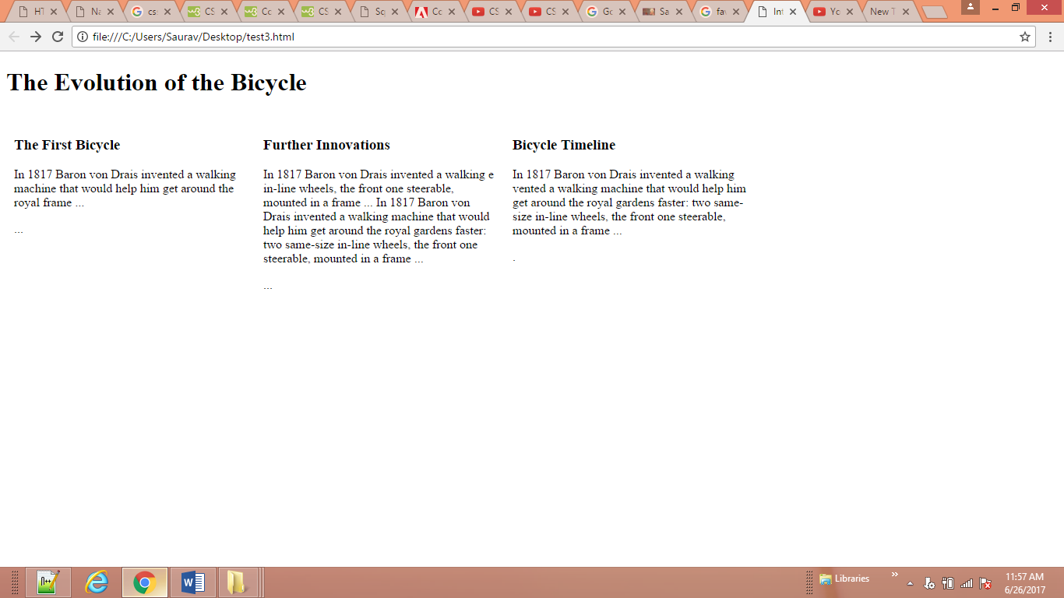

**A Fixed Width Layout**

<body>

<div id="header">

<h1>Logo</h1>

<div id="nav">

<ul>

<li><a href="">Home</a></li>

<li><a href="">Products</a></li>

<li><a href="">Services</a></li>

<li><a href="">About</a></li>

<li><a href="">Contact</a></li>

</ul>

</div>

</div>

<div id="content">

<div id="feature">

<p>Feature</p>

</div>

<div class="article column1">

<p>Column One</p>

</div>

<div class="article column2">

<p>Column Two</p>

</div>

<div class="article column3">

<p>Column Three</p>

</div>

</div>

<div id="footer">

<p>&copy; Copyright 2011</p>

</div>

</body>

**CSS**

body {

width: 960px;

margin: 0 auto;}

#content {

overflow: auto;

height: 100%;}

#nav, #feature, #footer {

background-color: #efefef;

padding: 10px;

margin: 10px;}

.column1, .column2, .column3 {

background-color: #efefef;

width: 300px;

float: left;

margin: 10px;}

li {

display: inline;

padding: 5px;}

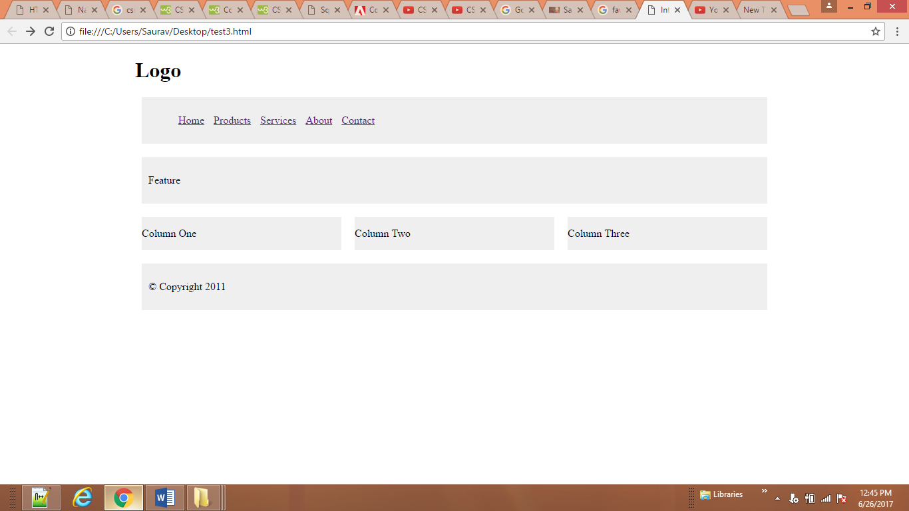

<body>

<div id="header">

<h1>Logo</h1>

<div id="nav">

<ul>

<li><a href="">Home</a></li>

<li><a href="">Products</a></li>

<li><a href="">Services</a></li>

<li><a href="">About</a></li>

<li><a href="">Contact</a></li>

</ul>

</div>

</div>

<div id="content">

<div id="feature">

<p>Feature</p>

</div>

<div class="article column1">

<p>Column One</p>

</div>

<div class="article column2">

<p>Column Two</p>

</div>

<div class="article column3">

<p>Column Three</p>

</div>

</div>

<div id="footer">

<p>&copy; Copyright 2011</p>

</div>

</body>

**CSS**

body {

width: 90%;

margin: 0 auto;}

#content {overflow: auto;}

#nav, #feature, #footer {

margin: 1%;}

.column1, .column2, .column3 {

width: 31.3%;

float: left;

margin: 1%;}

.column3 {margin-right: 0%;}

li {

display: inline;

padding: 0.5em;}

#nav, #footer {

background-color: #efefef;

padding: 0.5em 0;}

#feature, .article {

height: 10em;

margin-bottom: 1em;

background-color: #efefef;}

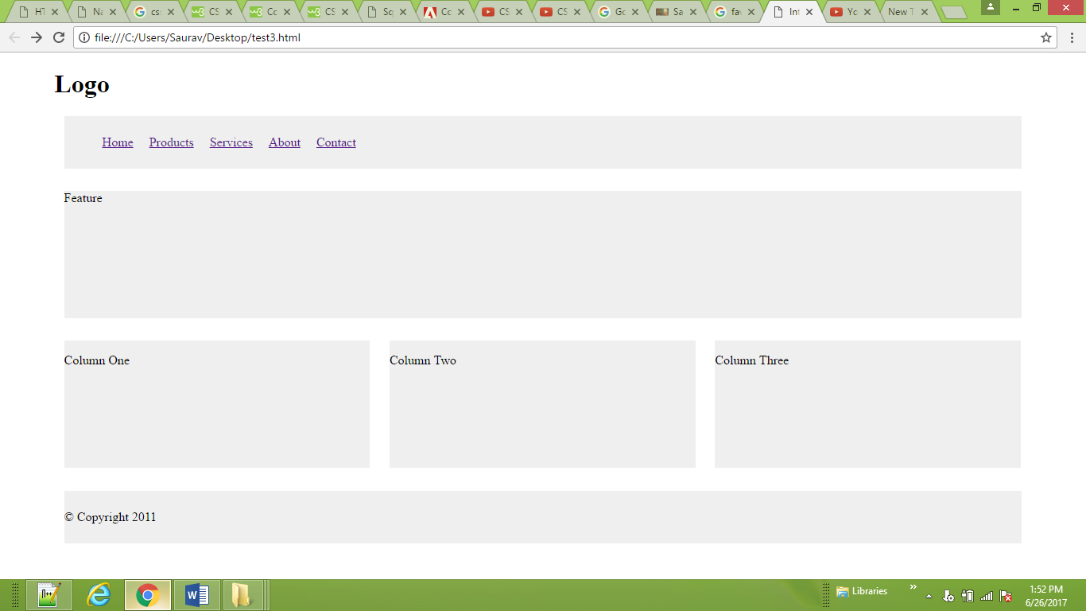

<body>

<img src="ram/feild.jpg" class="large" alt="sandarbh">

<br><br><br>

<img src="ram/feild.jpg" class="medium" alt="sandarbh">

<br><br><br>

<img src="ram/feild.jpg" class="small" alt="sandarbh">

</body>

**CSS**

img.large {width: 300px;

height: 300px;}

img.medium {width: 250px;

height: 250px;}

img.small {width: 100px;

height: 100px;}

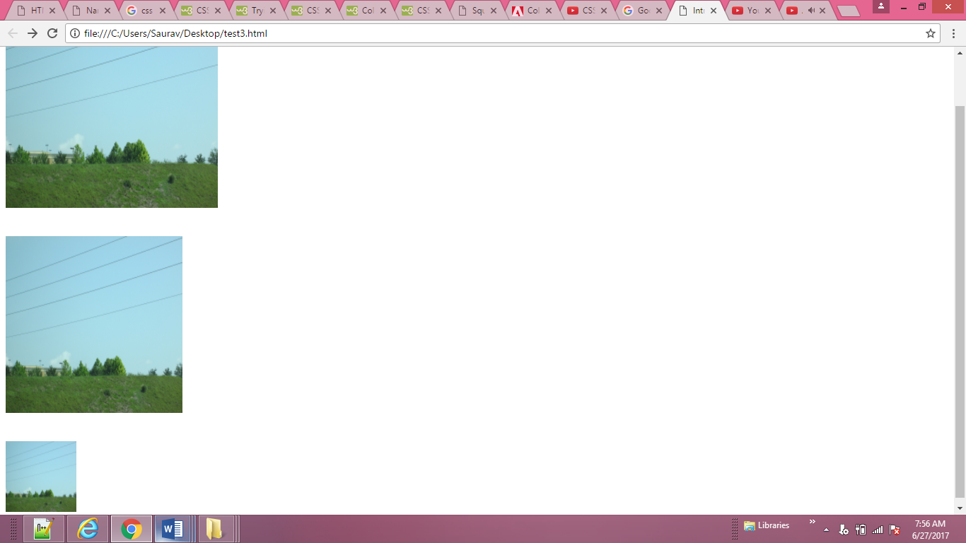

<body>

<p><img src="ram/feild.jpg" alt="Magnolia" class="align-left medium" /> <b><i>Magnolia</i></b> is a

large genus that contains over 200 flowering plant species...</p>

<p><img src="ram/feild.jpg" alt="Magnolia" class="align-right medium" /> Some magnolias, such as

<i>Magnolia stellata</i> and <i>Magnolia soulangeana</i>, flower quite early in the spring before the

leaves open...</p>

</body>

**CSS**

img.align-left {float: left;

margin-right: 10px;}

img.align-right {float: right;

margin-left: 10px;}

img.medium {width: 250px;

height: 250px;}

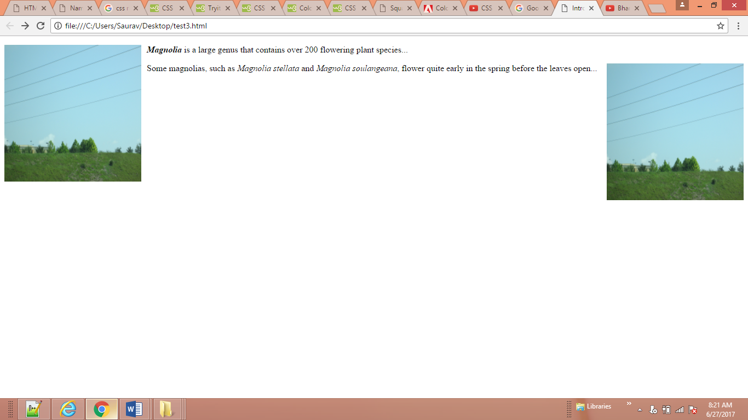

<body>

<p><img src="ram/feild.jpg" alt="Magnolia" class="align-center medium" /> <b><i>Magnolia</i></b> is

a large genus that contains over 200 flowering plant species is a large genus that contains over 200

flowering plant species. It is named after French botanist Pierre Magnol and, having evolved before bees

appeared, the flowers were developed to encourage pollination by beetle....</p>

</body>

**CSS**

img.align-center {display: block;

margin: 0px auto;}

img.medium {width: 250px;

height: 250px;}

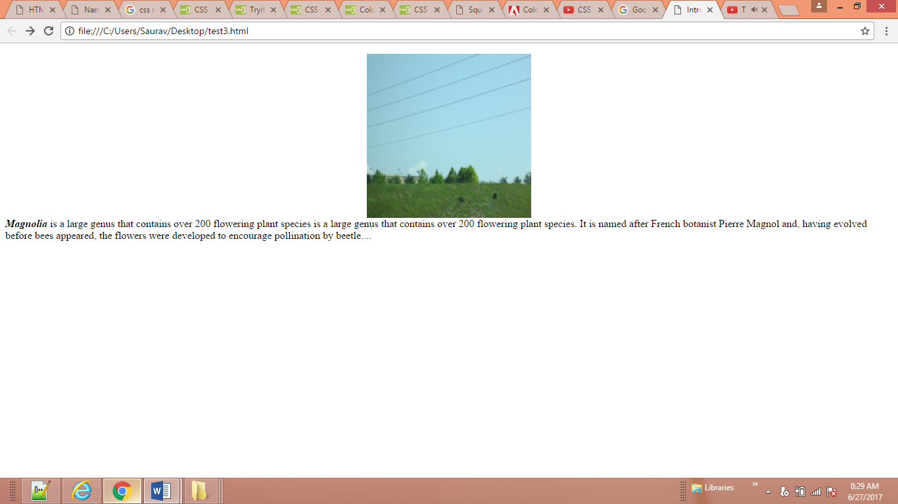

<body>

<h1> Literacy Story </h1>

<p> When I was in India, I never thought English was going to be a major problem for me. In my English

class I was getting grades which I needed to move to the next level of classes. I was in an English school

there, but I hardly found any students who spoke in English with other classmates or with the teachers.

Teachers were also speaking and explaining everything in Hindi to the students, and time was going fine

for me until

</p>

</body>

**CSS**

body {

background-image: url("ram/bground.jpg");

color: red;

}

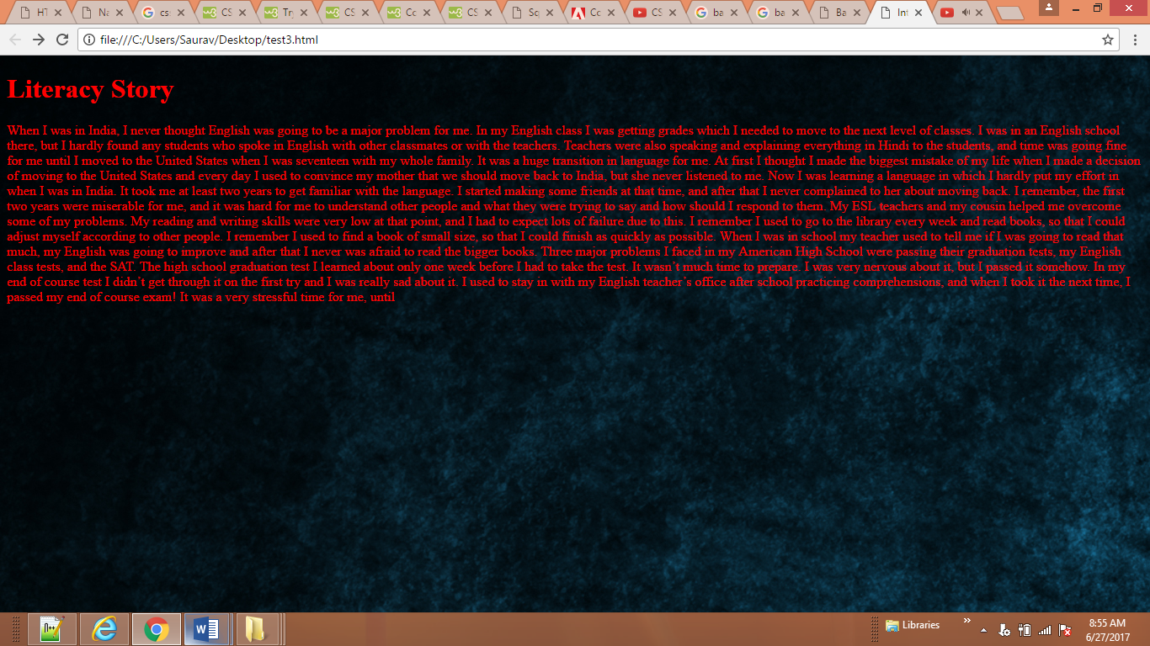

<body>

<h1> Literacy Story </h1>

<p> When I was in India, I never thought English was going to be a major problem for me. In my English

class I was getting grades which I needed to move to the next level of classes. I was in an English school

there, but I hardly found any students who spoke in English with other classmates or with the teachers.

Teachers were also speaking and explaining everything in Hindi to the students, and time was going fine

for me until

</p>

</body>

**CSS**

p {

background-image: url("ram/bground.jpg");

color: red;

}

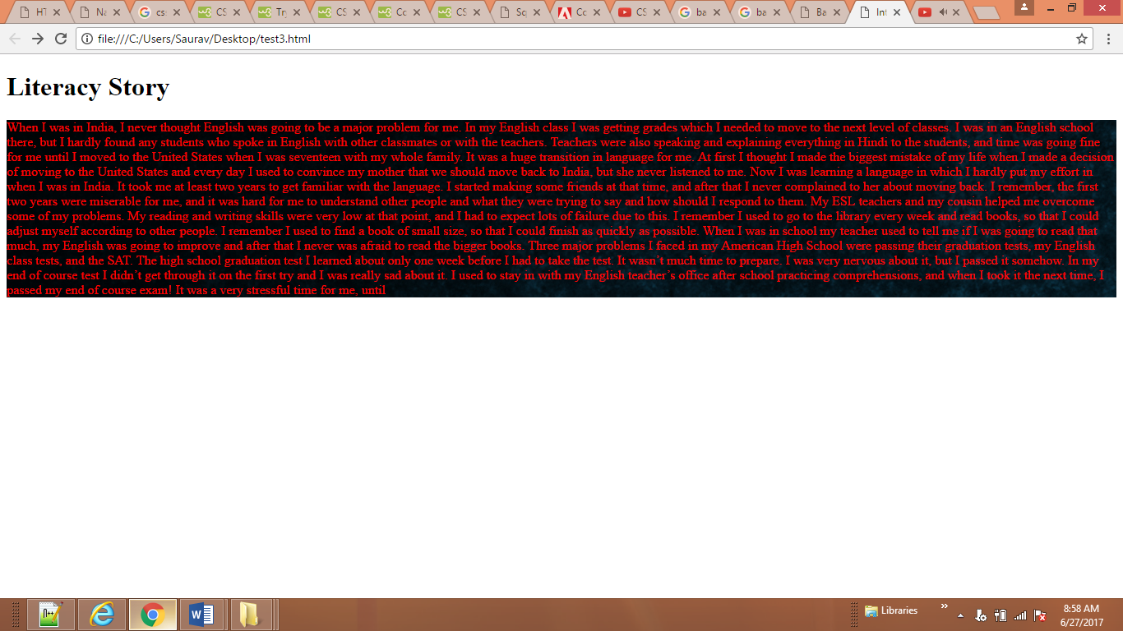

<body>

<h1> Literacy Story </h1>

<p> When I was in India, I never thought English was going to be a major problem for me. In my English class I was getting grades which I needed to move to the next level of classes. I was in an English school there, but I hardly found any students who spoke in English with other classmates or with the teachers. Teachers were also speaking and explaining everything in Hindi to the students, and time was going fine for me until I moved to the United States when I was seventeen with my whole family. It was a huge transition in language for me. </p>

</body>

CSS

body {

width:960;

height: auto;

background-image: url("ram/bg1.jpg");

background-repeat:repeat;

color:red;

}

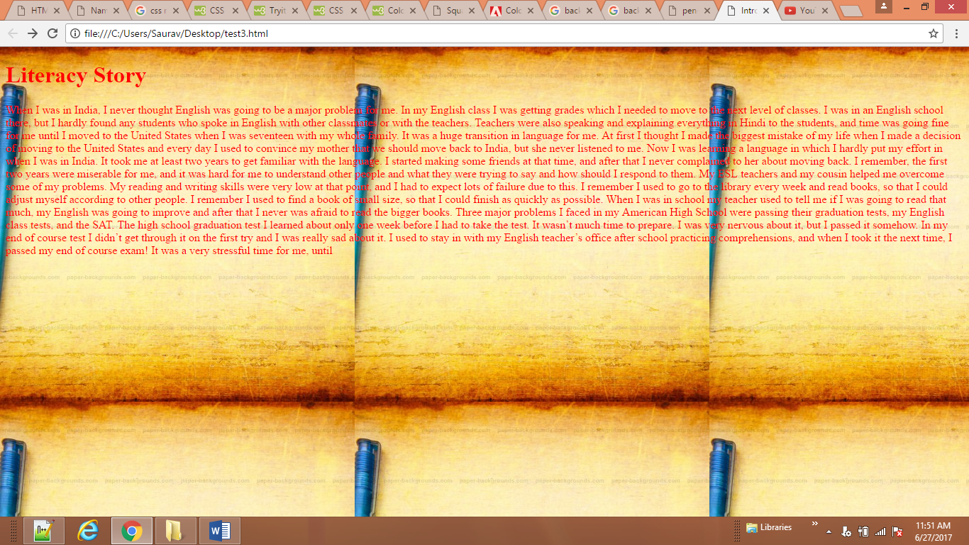

<body>

<h1> Literacy Story </h1>

<p> When I was in India, I never thought English was going to be a major problem for me. In my English class I was getting grades which I needed to move to the next level of classes. I was in an English school there, but I hardly found any students who spoke in English with other classmates or with the teachers. Teachers were also speaking and explaining everything in Hindi to the students, and time was going fine for me until I moved to the United States when I was seventeen with my whole family. It was a huge transition in language for me. </p>

</body>

**CSS**

body {

background-image: url("ram/bg1.jpg");

background-repeat:no-repeat;

background-position:left top;

color:red;

}

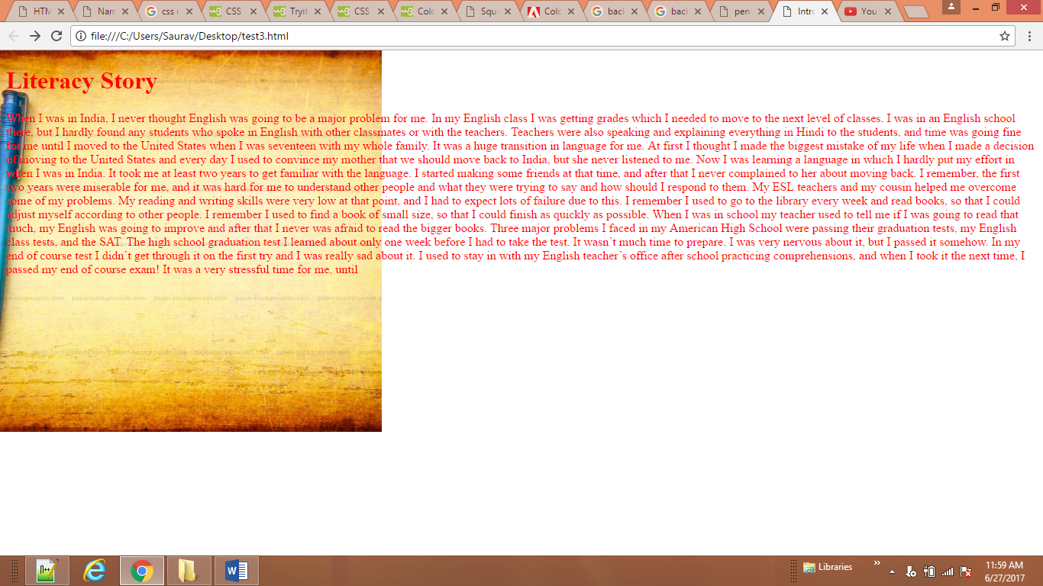

<body>

<h1> Literacy Story </h1>

<p> When I was in India, I never thought English was going to be a major problem for me. In my English class I was getting grades which I needed to move to the next level of classes. I was in an English school there, but I hardly found any students who spoke in English with other classmates or with the teachers. Teachers were also speaking and explaining everything in Hindi to the students, and time was going fine for me until I moved to the United States when I was seventeen with my whole family. It was a huge transition in language for me. </p>

</body>

**CSS**

body {

background: #FFffff url("ram/bg1.jpg")no-repeat top right;

}

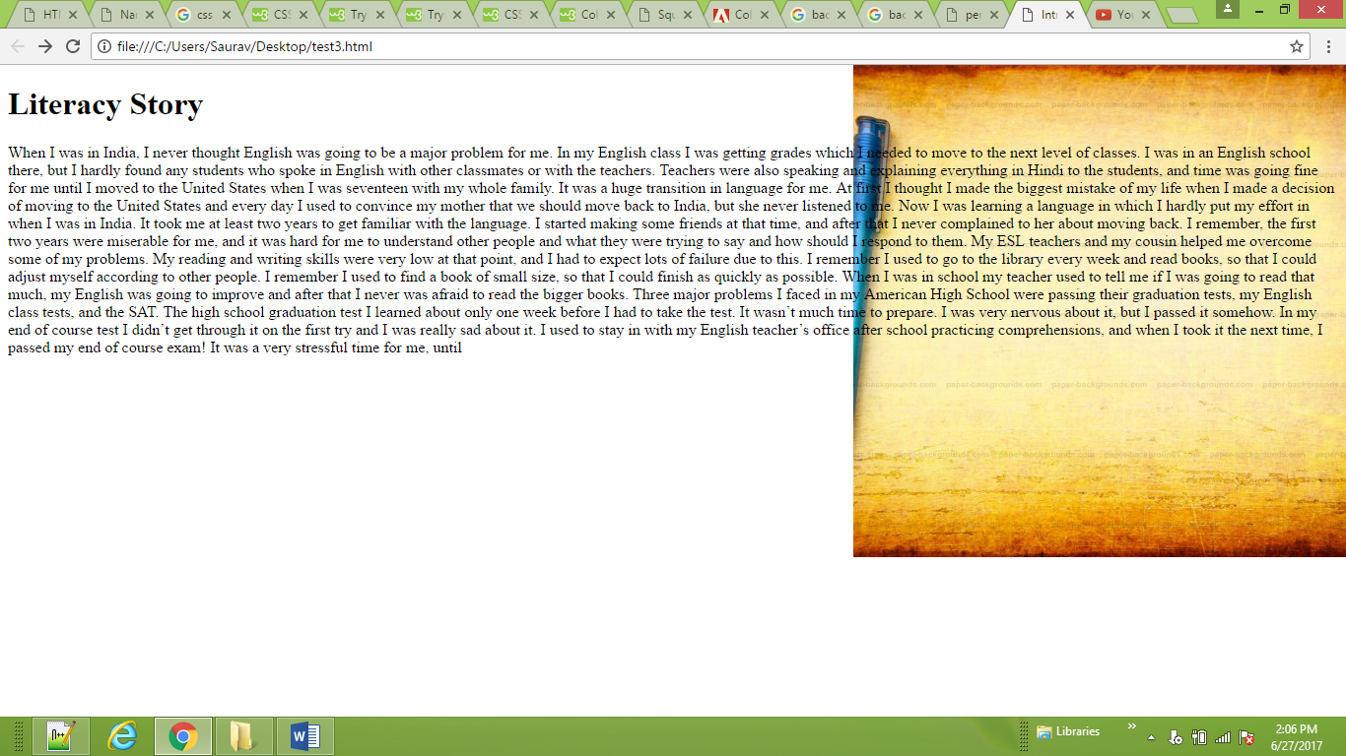

<body>

<h1> Literacy Story </h1>

<p id=”gradient”> When I was in India, I never thought English was going to be a major problem for me. In my English class I was getting grades which I needed to move to the next level of classes. I was in an English school there, but I hardly found any students who spoke in English with other classmates or with the teachers. Teachers were also speaking and explaining everything in Hindi to the students, and time was going fine for me until I moved to the United States when I was seventeen with my whole family. It was a huge transition in language for me. </p>

</body>

**CSS**

**#gradient {**

**/* fallback color */**

**background-color: #66cccc;**

**/* fallback image */**

**background-image: url(images/fallback-image.png);**

**/* Firefox 3.6+ */**

**background-image: -moz-linear-gradient(#336666,**

**#66cccc);**

**/* Safari 4+, Chrome 1+ */**

**background-image: -webkit-gradient(linear, 0% 0%,**

**0% 100%, from(#66cccc), to(#336666));**

**/* Safari 5.1+, Chrome 10+ */**

**background-image: -webkit-linear-gradient(#336666,**

**#66cccc);**

**/* Opera 11.10+ */**

**background-image: -o-linear-gradient(#336666,**

**#66cccc);**

**height: auto;**

**width: auto;}**

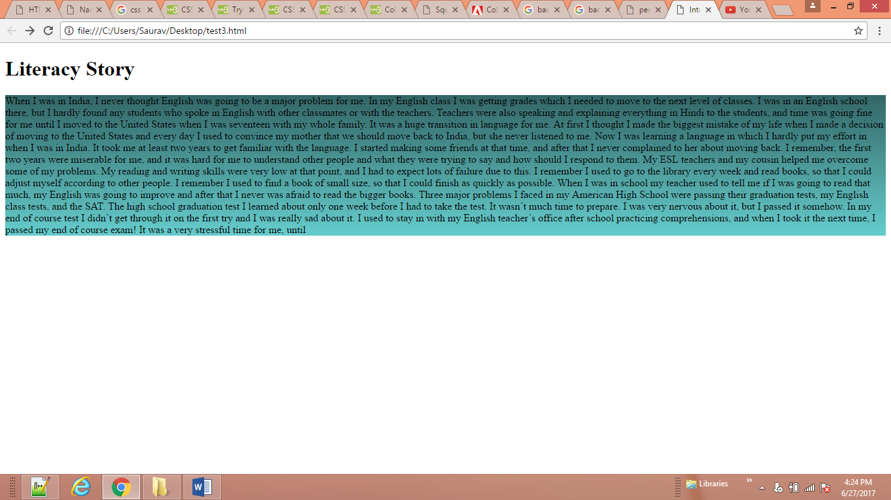

<body>

<header>

<h1>Yoko's Kitchen</h1>

<nav>

<ul>

<li><a href="" class="current">home</a></li>

<li><a href="">classes</a></li>

<li><a href="">catering</a></li>

<li><a href="">about</a></li>

<li><a href="">contact</a></li>

</ul>

</nav>

</header>

<footer>

&copy; 2011 Yoko's Kitchen

</footer>

</body>

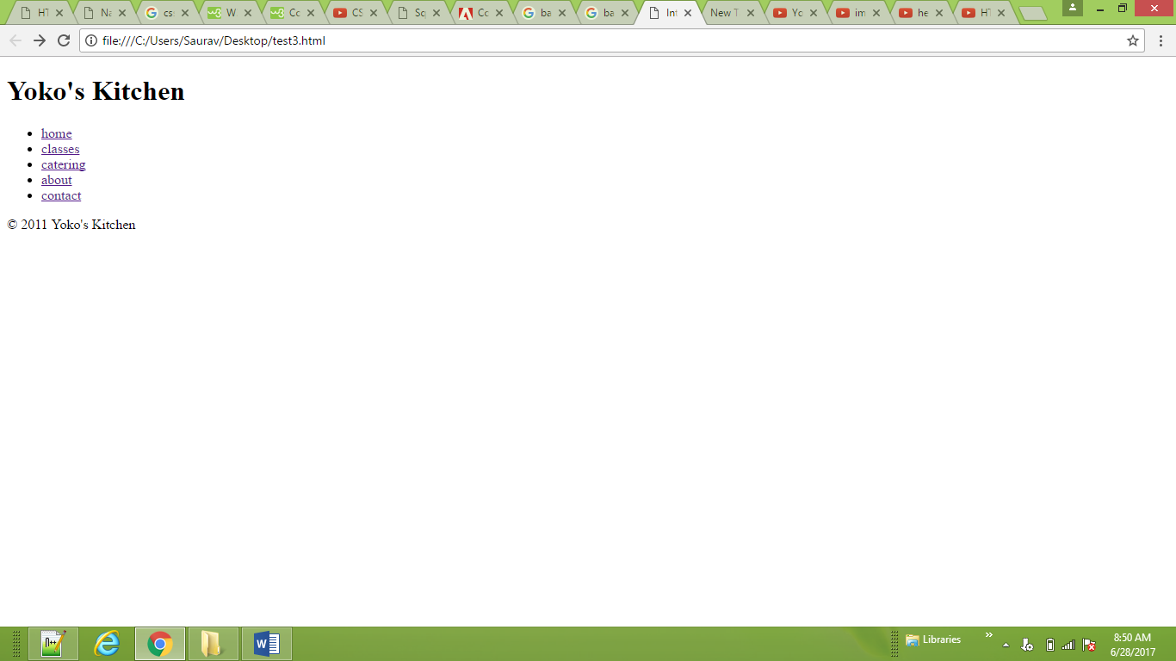

<body>

<nav>

<ul>

<li><a href="" class="current">home</a></li>

<li><a href="">classes</a></li>

<li><a href="">catering</a></li>

<li><a href="">about</a></li>

<li><a href="">contact</a></li>

</ul>

</nav>

</body>

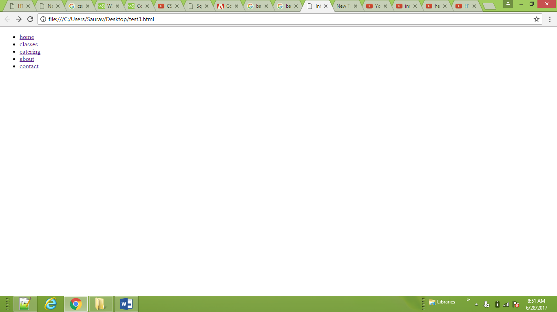

<body>

<a class="button" id="add-to-basket">

Add to basket</a>

</body>

**CSS**

a.button {

height: 500px;

width:500px;

background-image: url("ram/nf.jpg");

display: inline-block;}

a#add-to-basket {

background-position: 0px 0px;}

a#add-to-basket:hover {

background-position: 0px -40px;}

a#add-to-basket:active {

background-position: 0px -80px;}

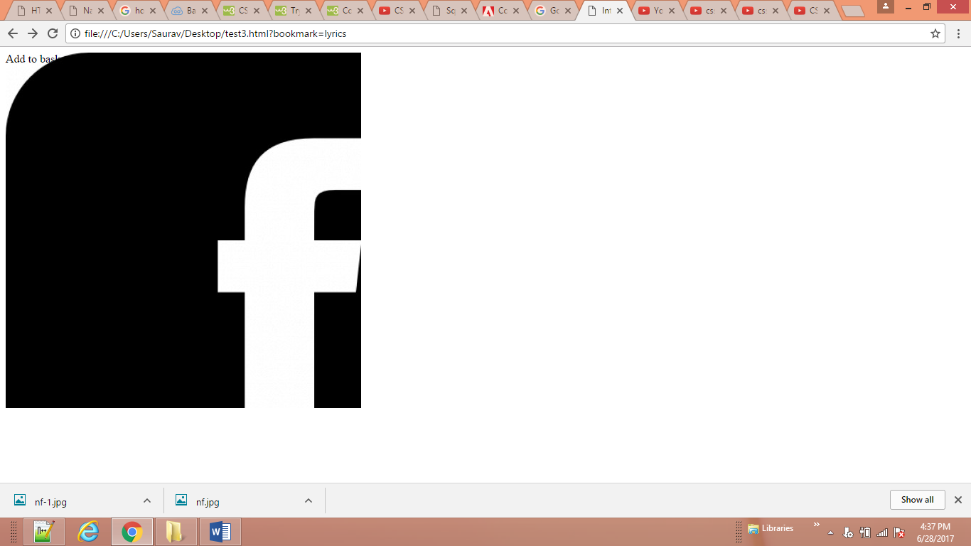

<body>

<a href="https://www.facebook.com/"> <img src="'ram/nf.jpg'" onmouseover="this.src='ram/nf-2.png'"

onmouseout="this.src='ram/nf.jpg'"></a>

</body>

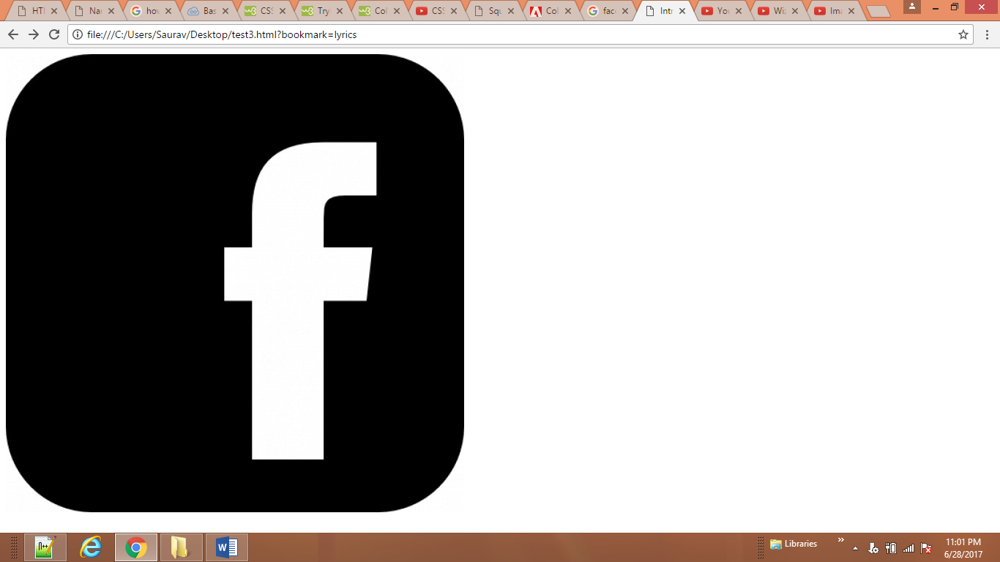

<body>

<article>

<figure>

<img src="ram/nf.jpg" alt="Bok Choi" />

<figcaption>Bok Choi</figcaption>

</figure>

<hgroup>

<h2>Japanese Vegetarian</h2>

<h3>Five week course in London</h3>

</hgroup>

<p>A five week introduction to traditional Japanese vegetarian meals, teaching you a selection of rice

and noodle dishes.</p>

</article>

<article>

<figure>

<img src="ram/nf-1.jpg"

alt="Teriyaki sauce" />

<figcaption>Teriyaki Sauce</figcaption>

</figure>

<hgroup>

<h2>Sauces Masterclass</h2>

<h3>One day workshop</h3>

</hgroup>

<p>An intensive one-day course looking at how to

create the most delicious sauces for use in a

range of Japanese cookery.</p>

</article>

</body>

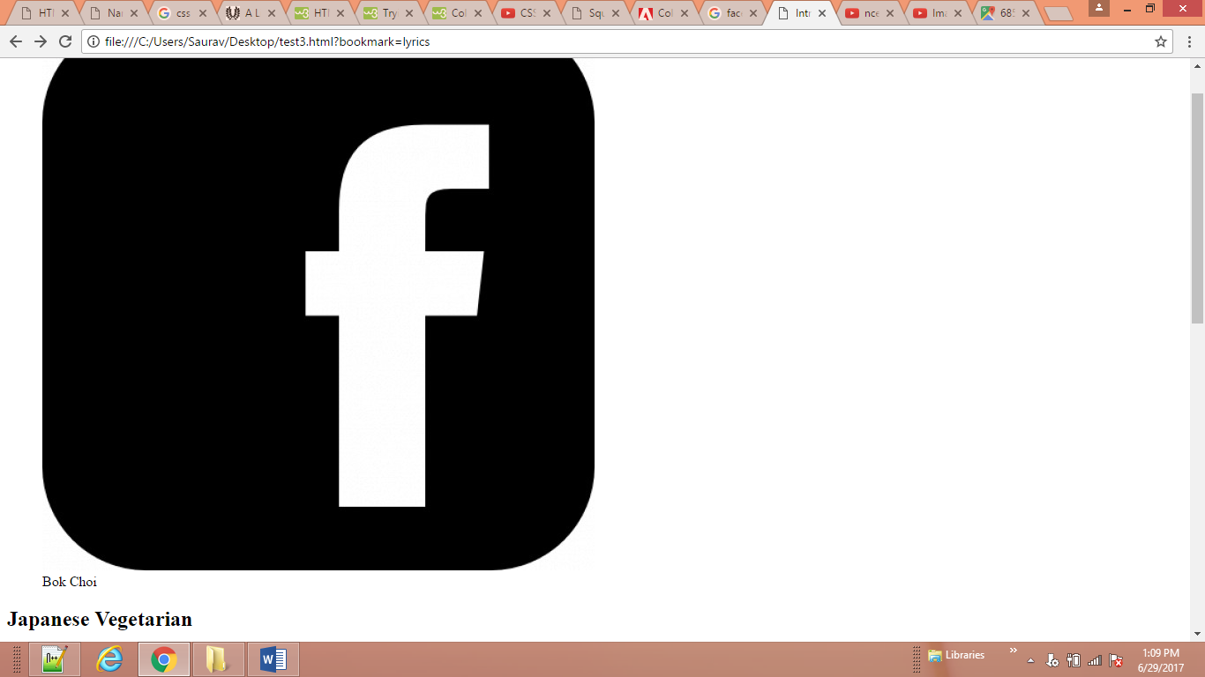

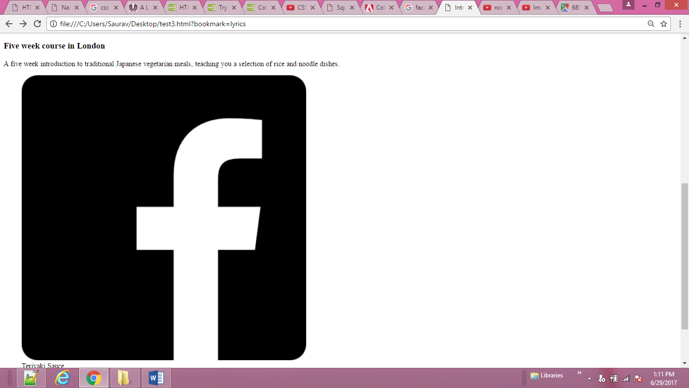

<body>

<aside>

<section class="popular-recipes">

<h2>Popular Recipes</h2>

<a href="">Yakitori (grilled chicken)</a>

<a href="">Tsukune (minced chicken patties)</a>

<a href="">Okonomiyaki (savory pancakes)</a>

<a href="">Mizutaki (chicken stew)</a>

</section>

<section class="contact-details">

<h2>Contact</h2>

<p>Yoko's Kitchen<br />

27 Redchurch Street<br />

Shoreditch<br />

London E2 7DP</p>

</section>

</aside>

</body>

